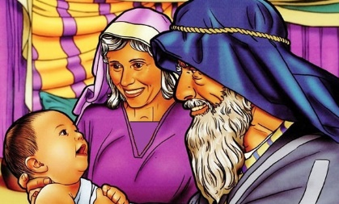
ISAAC, SON OF PROMISE
Genesis 15:4-5; 21:1-21
22:1-19
February 4, 2018
1-1-9

God made three promises to Abraham when He asked Abraham to leave his home. God promised to give him the land of Canaan. He promised Abraham’s descendants would become a great nation and that all nations would be blessed through Abraham’s family.
Abraham couldn’t have descendants, though, without having children. That’s why Sarah tried to take matters into her own hands and get a child through Hagar. Finally, when God was ready and Abraham was 100 years old, Sarah and Abraham had a son and they called him Isaac! God told Abraham that through Isaac, his descendants would be blessed.
Sarah didn’t want Ishmael around to become an heir with Isaac and asked Abraham to send Hagar and Ishmael away. This troubled Abraham, but the Lord said, “The son of the maid, Hagar, I will make a nation also, because he is your descendant.” Abraham gave them bread and water and sent them away and they wandered in the wilderness of Beersheba. When their supplies ran out, she lifted her voice up and wept and the child cried too, but God heard the crying and the angel of God said, “Do not fear, for God has heard the voice of your child and will make him a great nation. God opened her eyes and she saw a well of water. They drank and the child grew and became an archer.
Then God decided to test Abraham. He told Abraham to take Isaac to Moriah and offer him as a burnt offering. Abraham immediately obeyed and he set out with Isaac and everything he would need for the burnt offering. When they arrived, Isaac asked where the lamb was for the burnt offering. Abraham answered that God would provide. Abraham built an altar, bound Isaac and put him on top of the altar. He was about to kill Isaac when the angel of the Lord stopped him and provided a ram to sacrifice in Isaac’s place. God told Abraham that because he didn’t withhold his only son that Abraham would be greatly blessed.
Abraham was asked by God to sacrifice his son through which he was to have many descendants. He never questioned God or doubted God’s plan. He had tremendous faith that God’s promise to him would still be fulfilled. All of his trust was in God. Abraham is a great example to us today of how we should also trust God.

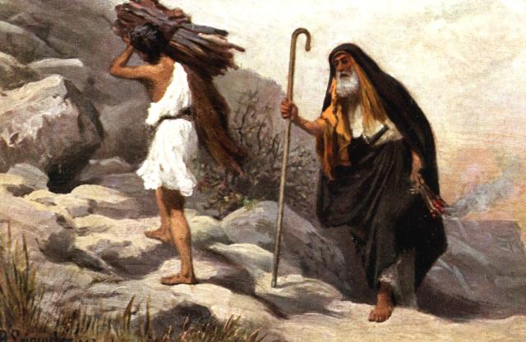

Questions: Find the facts
- How old was Abraham when Isaac was born? (Gen. 21:5)
- What happened to Hagar & Ishmael? Why?

- What did God do for Ishmael?

- What did God ask Abraham to do? (Gen. 22:2)

- What happened to Isaac?
Thought Questions:
(Bring your thoughts to class or write on the back of the page.)
- Read John 3:16. Who else sacrificed a son He loved? Was His son obedient like Isaac?

- Which sacrifice gives you a chance to be a child of Abraham?

From Old Testament to New Testament
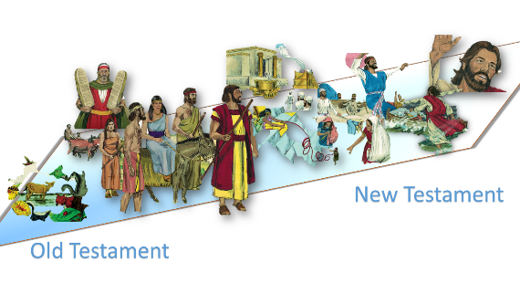
- Read Hebrews 11:19. What did Abraham think would happen when he sacrificed Isaac?

- By following through on the test that God gave to Abraham, what does that do for you and me today?

- Read 1 John 3:1. If we are Abraham’s children, what else are we called?

- Read James 2:21-24. How did Abraham show his faith?

- How can YOU show YOUR faith?

