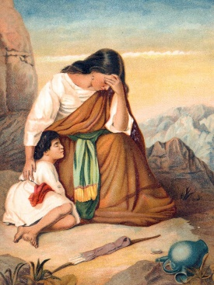
HAGAR AND ISHMAEL
Genesis 16
January 28, 2018
1-1-8

God promised Abram that he would have many descendants and become a great nation but he and his wife Sarai had grown very old and still had no children. Sarai was impatient so she decided to take matters into her own hands. She had an Egyptian maid name Hagar and she gave Hagar to Abram as his second wife. When Hagar became pregnant, Sarai began treating her harshly. Hagar ran away because she could not bear to be treated so badly. An angel of the Lord found Hagar and told her to return to Sarai. The angel also said that the Lord would multiply her descendants so much that they could not be counted. She was told she would have a son and he would be called Ishmael. So Hagar went back to Sarai. She gave birth to a son and Abram named him Ishmael. Then God gave Abram the new name of Abraham and to Sarai, He gave the name Sarah.

Questions: Find the facts

- Whose idea was it to have Abram have a child with Hagar?

- How did Hagar behave toward Sarai after she found out she was having a child?

- What did Sarai do to Hagar in response to Hagar’s pregnancy?

- Who found Hagar and what did he tell her to do?

- What does the name “Ishmael” mean?

- How old was Abram when Ishmael was born?

- Did Sarai think that she was “helping God” when she told Abram to have a baby by her servant Hagar? Was this God’s plan?

- What did the Angel of the Lord tell Hagar about what would happen to Ishmael?
#1____________________________ #2________________________

Thought Questions:
(Bring your thoughts to class or write on the back of the page.)
Sarai keeps getting older and older and still does not have any children. She begins to lose her faith in God’s promise. What might God be teaching her by asking her to continue waiting?

From Old Testament to New Testament
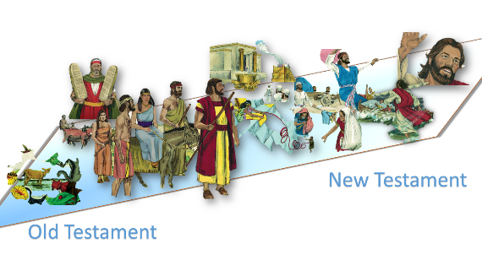
Read Galatians 4:22-31. Ishmael was the son of a servant and would always be a servant, but Isaac was the son of promise and so would always be free. What Paul is talking about here is that those who are saved by faith will be free (because Jesus came from this promise), but those who try to find salvation with the Old Law alone are still slaves.

