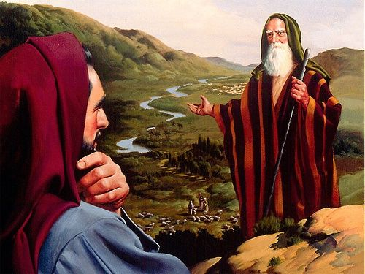
ABRAM & LOT
January 24, 2018
Genesis 13, 14, 19
1-1-7

Please read Genesis: 13:5-18, 14:11-24, 18:20-33, 19:1-3, 19:12 and 19:24-26
Abram and Lot were living between the cities of Bethel and Ai and both men were rich with flocks, herds and tents. Their herdsmen argued over pasture land because the land was not large enough for all the animals to graze and the people to live.
Abram didn’t want conflict between the families and offered Lot first choice where he would like to live. Lot chose all the valley of the Jordan because it was well watered and he moved his tents near Sodom where the men were very wicked and sinners against the Lord. Abram on the other-hand, settled in the land of Canaan and moved his tent and lived by the oaks of Mamre in Hebron and built an altar to the Lord.
Years passed and the kings of the land battled each other and took all the goods of Sodom and Gomorrah, all their food supply, Lot, Abram’s nephew, his family as slaves and Lot’s possessions and departed. When Abram heard this he led 318 of his well-trained men out to rescue Lot. After God helped Abram defeated King Chedorlaomer, the King of Sodom wanted Abram to leave the people and take the goods for himself. Abram refused because he made a promise to God that he would not take anything that belonged to the King of Sodom so the King would not say he made Abram rich. Abram would only take what his men had eaten and that was all.
Later, God hear the outcry of Sodom and Gomorrah because their sin was exceedingly grim and the Lord went down to see and planned to destroy the cities if all he heard was true. Abraham asked God if he would destroy the cities if 50 righteous people could be found and remarked to God, “Far be it from You to do such a thing, to slay the righteous with the wicked, so that the righteous and the wicked are treated alike. Shall not the Judge of all the earth deal justly?” So the Lord God said if he found 50 righteous within the city he would spare the whole place. Abraham would continue to ask God how many righteous people found in the city would it take for God to spare the cities and God stopped by saying if ten righteous were found, He would spare the city.
Before this conversation, God sent two angels to Sodom with the intention to destroy the city because of its outcry had become so great before the Lord. Lot was told to get his wife and two daughters and leave with them immediately and they did. The angels told them not to look back, however, Lot’s wife did and was turned into a pillar of salt as the Lord rained on Sodom and Gomorrah brimstone and fire from the Lord out of heaven.

Questions: Find the facts

- Why did Abram and Lot part ways?

- Why did Lot choose the land that he did?

- How did Abram help Lot in Genesis 14?

- Did Abram accept anything from the King of Sodom? Why?

- In Genesis 18, Abraham asks God not to destroy Sodom and Gomorrah. How many people had to be faithful for God NOT to destroy the cities?

- In Genesis 19, what were the two angels/men brought to Sodom to do?

Thought Questions:
(Bring your thoughts to class or write on the back of the page.)
What can we learn about God from Abram’s conversation in Genesis 18:20-33?

How did Lot’s decisions as a father and leader of his family affect his family?

From Old Testament to New Testament
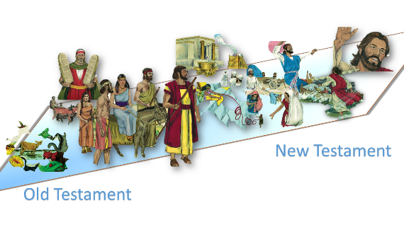
In Genesis 14:18-20 we are introduced to a king named Melchizedek. Read Hebrews 5:5-6. Who else is like King Melchizedek?

