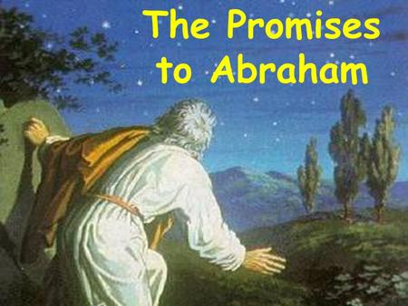
GOD’S PROMISE TO ABRAHAM
January, 21, 2018
Genesis 11-12
1-1-6

After the flood, the earth again became full of people living in many lands. Many people worshipped idols and other gods but there was one man living in a city called Ur who worshipped and prayed to the one true God. His name was Abram. God spoke to Abram and told him to leave his home and journey to a new land called Canaan. God told Abram that He would give Canaan to Abram and his descendants, that He would make of them a great nation, and that all families of the earth would receive a blessing through Abram.
Even though Abram had lived in Ur for a long time and he did not know what he would face in the new land, he packed up his family and headed to Canaan. He put his trust in God and he had faith that God would take care of him.
God did take care of Abram. He gave the land of Canaan to him and his descendants. His descendants became the great nation of Israel, and Jesus, the Savior of the world was the great blessing that came from Abram’s family.
God made promises to Abram and He kept them. God always keeps His promises.
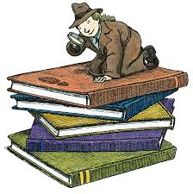
Questions: Find the facts

- Which of Noah’s sons was Abram related to?

- God tells Abram to leave three things in 12:1. What are they?_________, ___________, _________

- What are the three main parts of God’s promise to Abram
#1_____________ #2_____________ #3_____________

- What was the first thing Abram did when God showed him his land in 12:7?

- What happened to Pharaoh’s house because of Abram’s lie about Sarai, his wife?

- This lesson is very important because it introduces us to a promise of God. Is Abram the only person this promise is important to?

- Part of God’s promise to Abram involves many children (a great nation). But, his wife Sarai can’t have children. What is God asking Abram to do? (hint: Read Hebrews 11:8-11)

Thought Questions:
(Bring your thoughts to class or write on the back of the page.)
Abram is the patriarch (the head) of the Jews. They thought very highly of him! Yet, he made a mistake when he lied to Pharaoh and didn’t trust that God would take care of him. What do you think he learned through this mistake and what lesson do we learn about God?
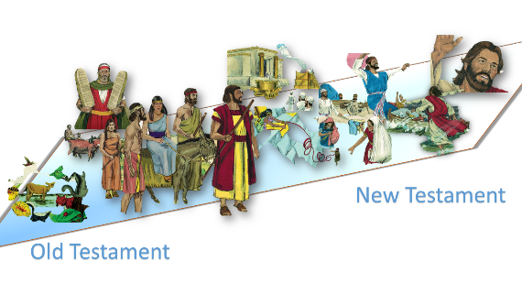
From Old Testament to New Testament
We will be spending quite a bit of time following God’s promises to Abram through the Bible. Read Acts 3:24-26 to find who the “blessed seed” is: _____________

