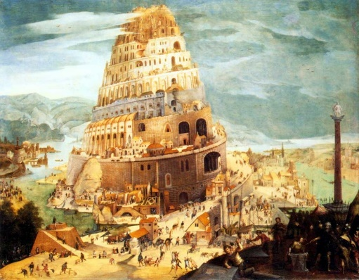
TOWER OF BABEL
January 17, 2018
Genesis 11:1-9

1-1-5

Noah lived three hundred and fifty years after the flood and was nine hundred and fifty years old when he died. Noah’s sons Shem, Ham and Japheth blessed him with many children and generations of grandchildren.
Now the whole earth used the same language and the same words. The descendants of Noah found a plain in the land of Shinar and settled there. They said to one another, “Come, let us build for ourselves a city and a tower whose top will reach into heaven, and let us make for ourselves a name, otherwise we will be scattered abroad over the face of the whole earth. The Lord saw what the people were trying to accomplish by themselves. The Lord said, “Behold, they are one people and they all have the same language and now nothing which they purpose to do will be impossible for them.” Therefore, the Lord confused their language, so that they would not understand one another’s speech and scattered them over the whole earth and they stopped building the city whose name was known as Babel.
Questions: Find the facts

- How was it that everyone understood each other?

- Where did the descendants of Noah settle?

- Why did the people want to build a city with a tower?

- What was wrong with this plan?

- Why did God confuse their language?

- What happened to their city?

- What did the city become known as? Why is this name appropriate?

Thought Questions:
(Bring your thoughts to class or write on the back of the page.)
Were the people WRONG for wanting to build a tower and a city?
If so, what was their sin? Or, if not, when why?

From Old Testament to New Testament
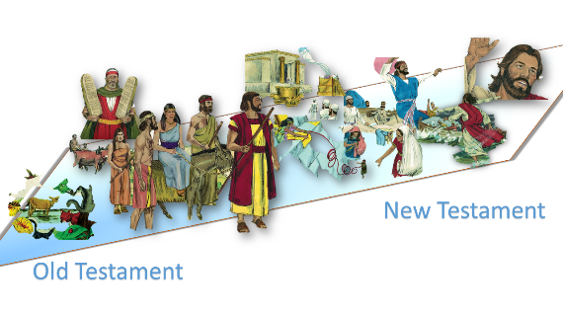
In our text, the people were building themselves on their human attributes.
Read Luke 14:11 and 1 Peter 5:5-7, what should we build ourselves on and what is our reward if we do?

