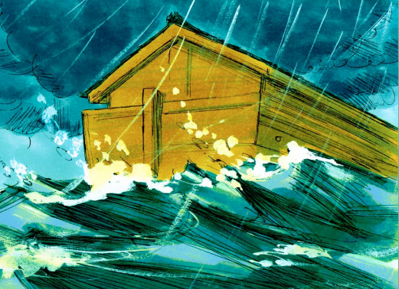
NOAH AND THE FLOOD
January 14, 2018
Genesis 6-9
1-1-4

As the population on earth continued to grow, mankind became increasingly wicked, evil, corrupt and violent. The evil was so great that God became sorry that he had created man and was sad in His heart and decided to punish the wicked by destroying them. One man named Noah, however, found favor in God’s eyes. Noah was righteous, blameless and walked with God. God told Noah that He was going to save Noah and his family and all others would perish in a flood that God would bring on the earth. God gave Noah specific instructions to build a large ark that would float when the flood came and keep them and the special cargo safe. Noah obeyed God exactly. He built the ark. He and his wife, his three sons Shem, Ham and Japheth and their three wives boarded the ark. God told them to take along with every them clean animal by sevens and every unclean animal by twos.
The flood came. Every living creature perished except those on the ark. The flood lasted for 150 days and Noah and his family remained safe on the ark. Then God sent a wind to dry the land. The ark came to rest on Mt. Ararat.
God recognized that Noah was a righteous man. He told Noah that He would save him and his family and He did. God always keeps His promises. God also said that He would never flood the earth again and He set the rainbow in the sky as a reminder of this promise to man.

Questions: Find the facts

- How does God feel when men choose to live against His commands? (6:6-8)

- Where did Noah and his family find safety, both physically and spiritually?

- Who did God choose to build the ark? Why?

- Why did God decide to destroy all living things on the earth?

- How many people went into the ark? Who were they?
(Read 1 Peter 3:20)

- What did Noah do after he came out of the ark onto dry land?

Thought Questions:
(Bring your thoughts to class or write on the back of the page.)
Genesis 6:9 says that Noah walked with God. This is a very powerful statement. What does it mean and can we walk with God too?

From Old Testament to New Testament
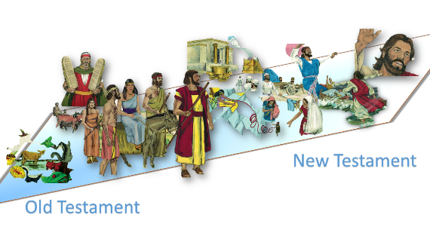
Genesis 6:5 talks about evil hearts of the men on earth. They all died for this in the flood. Does God feel differently about what is in our heart today?
Read Matthew 15:18-19

