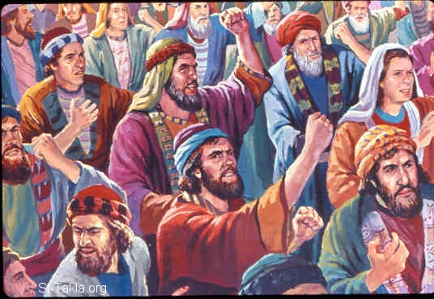ISRAEL’S COMPLAINS
April 25, 2018
Numbers
2, 11:1-2,
14:1-5,
Ps 78:21-35
1-1-32

The Lord speaks to
Moses and Aaron and tells them to separate the children
of Israel by tribes. God has a special location for each tribe to
Camp around the Tabernacle which would be in the center. God
counts the tribes and numbers each and calls them armies. Do you suppose God is preparing them for a battle?
Guess what, the children of Israel are complaining again! They are tired of eating the same thing everyday. They aren’t content with having manna and not being hungry, but they are focused on what they don’t have. They miss the fish, melons, cucumbers onions and garlic that they ate in Egypt. They want meat. The Lord is displeased, get angry and sends fire and kills some in the outskirts of the camp. The people cry to Moses and Moses prays to the Lord and the fire is quenched.
The people are camping in the Wilderness of Paran now. The Lord speaks to Moses and tells him to send out 12 men, one from each tribe, to spy out the land. They are suppose to check out to see if the people are strong or weak, few or many and whether the land is good or bad, rich or poor and the cities like camps or forts. The spies leave and return after 40 days. All the men said the land truly flows with milk and honey and the fruit is plentiful and good, HOWEVER, the people are strong, cities are forts and large and the Amalekites and other warrior people live there. Ten of the men say they can’t not go up against those people for they are stronger. The people cried because of this bad report and complain against Moses and Aaron and said “Why has the Lord brought us to this land to fall by the sword and our wives and children should become victims. It would be better for us to return to Egypt.” They even wanted a new leader! But Caleb and Joshua said, “The land is exceedingly good and if the Lord delights in us, then He will bring us into this land and give it to us. Do not rebel against the Lord, nor fear the people of the land. The Lord is with us and not them.”
God responds, “How long will these people reject me? Because these people have seen my glory, the signs which I did in Egypt and in the wilderness and still have put Me to the test and not listened to my voice, I will not allow them to see the promised land that I promised their fathers.” Here is the unbelieving children of Israel’s consequence for there disbelief. Only Caleb and Joshua and the children of the 10 tribes will see Canaan.
Think about why you complain. What will help us not complain?

Questions: Find the facts
- Where was the Tabernacle placed in the camp?

- What is each tribe called when they are counted in Numbers 2?
(Hint : Are they ready to fight?)

- What did the Hebrews do even after God provided for them? (Numbers 11:1-2)

- What was God’s response?

- The complaining gets so bad in Numbers 14 that the Israelites want to do what?

Thought Questions: (Bring your thoughts to class or write on the back of the page.)
The In Numbers 2 and 3 all of the children of Israel are counted. What do you think is the purpose of this count or census? (Hint: Does it have anything to do with one of the promises to Abraham?)

Do you think there is a reason for God to keep the different tribes a little separate from each other?

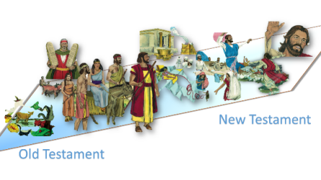From Old Testament to New Testament
Look at I Corinthians 10:10-13. Paul talks here about what happened to the Israelites when they complained. What does Paul say we should understand that will help us not to complain?

