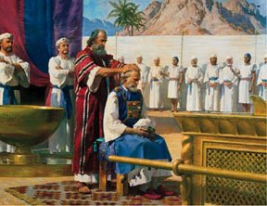
THE LEVITES BECOME PRIESTS
Leviticus
8-10
April 22, 2018
1-1-31

After the Tabernacle was finished, the Lord told Moses
to bring Aaron and his sons to the doorway of the tent of meeting and wash them with water. Then Moses was to put the holy garments on Aaron and anoint him so that Aaron could minister as a priest to the Lord. Moses was also to put tunics on Aaron’s sons. They were to be anointed also as priests. Descendants of Aaron and his sons would also be priests. Aaron and his sons were of the tribe of Levi. Priests could only come from that tribe. Aaron and his sons were the first priests of the Israelites.
The priests had very important responsibilities. They would offer sacrifices to the Lord on behalf of the Israelites. Animal sacrifices were offered so the people could have forgiveness of their sins. Over and over and over animal sacrifices were made but the blood of bulls and goats does not take away the sins of man. That is why God sent His son to die on the cross. Jesus was the sacrifice needed to forgive us of our sins.
Questions: Find the facts
- From which tribe were the priests chosen? (Numbers 8:5-6,19)

- In Leviticus chapter 8, we see what God told Moses to do to “consecrate” Aaron as a priest. This meant he was setting Aaron apart, making him special in God’s service. List some things that Moses did to consecrate Aaron. (Lev. 8:1-9)

- How long were Aaron and his sons told to stay inside the Tabernacle before they could come out ot make offerings for the people? (Lev. 8:33-36)

- How were the sins of the Israelites forgiven? (Lev. 9:1-7)

- What was the sin of Nadab and Abihu’s ? (Lev. 10:1-2)

- What was the consequence of Nadab and Abihu’s sin?

Thought Questions: (Bring your thoughts to class or write on the back of the page.)
The Why might God have chosen the Levites to be the priests?
(Hint: Read Ex. (Hint read Ex. 32:25-29)

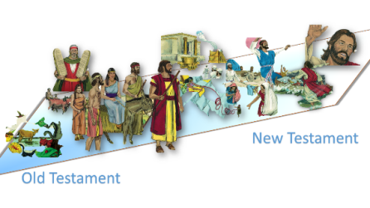
From Old Testament to New Testament
Who is better than the Levitical priests and even Aaron the high priest and why? (Read Hebrews 8:1-2, 7-13)

Who is our High Priest today? (Hebrews 4:14-16)

