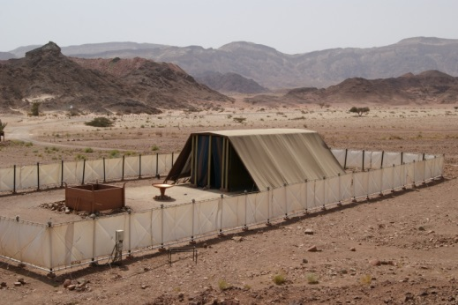THE TABERNACLE
Exodus
35:20-29 36:8-9
37:1-9
40:18-38
April 18, 2018
1-1-30

God gives special instructions to Moses about
how and where to worship him. God is very specific about when to work and when not to work. Work is only to be done for six
days and then on the seventh day it shall be a holy day and a Sabbath of rest to the Lord. Whoever did any work on the Sabbath would be put to death.
The children of Israel are to start building a tabernacle for God to dwell among them. God gives Moses the plans and patterns to communicate His instructions to the men and women who were gifted artisans. But first they need supplies. Here are some of the supplies they needed in Exodus 25:1-7. People with stirred hearts and whose spirits were willing brought the Lord’s offering for the work of the tabernacle of meeting, for all its service and for the holy garments.
Those with special skills offered to help make the tabernacle’s framing, covering, furnishings, utensils priest’s garments. In fact, there were so many offerings and workers that Moses gave a command to stop working and bringing offerings because they had sufficient help and supplies to complete the work according to the Lord’s commands.
Finally the tabernacle parts were completed and the Lord told Moses to raise it up on the first day of the first month. Moses finished the work according to the Lord’s command. Then the cloud covered the tabernacle of meeting, and the glory of the Lord filled the tabernacle. The children of Israel would know when it was time to continue their journey toward Canaan whenever the cloud was taken up from above the tabernacle. But if the cloud stayed over the tabernacle, they stayed camped. The cloud of the Lord was over the tabernacle by day and fire was over it by night in the sight of all the house of Israel throughout all their journeys. God was with His people all the time!
Questions: Find the facts
- What was the penalty for working on the Sabbath? (Ex. 35:2)

- What pieces of furniture were in the Tabernacle? (Ex. 40:18-38)

  - ______________
  - ______________
  - ______________
  - ______________
  - ______________
  - ______________
- How did the children of Israel know when it was time to continue traveling? (Ex. 40:36-38)

- Did God’s plan for making the Tabernacle allow everyone to be involved?
(Ex. 35:22)

  - Who was responsible for the metal and woodworking?(Ex. 35:30-34)

  - The tapestries? (Ex. 35:34-35)
  - How much did the children of Israel bring for their offering? Just enough to get the job done? (Ex. 36:5)

- Just when we were starting to worry the Israelites would never make it, they complete this amazing Tabernacle for God. What did Moses think about this and what did he do? (Ex. 39:42-43)

Thought Questions: (Bring your thoughts to class or write on the back of the page.)
The God “signs” His covenant, or contract, with the Hebrews by establishing a formal way that they can worship Him. This tabernacle is something that they can see and believe. What portion of the promise to Abraham is completed here?

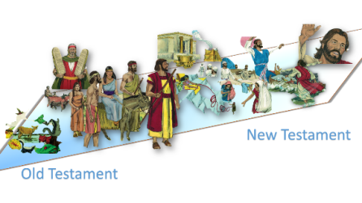From Old Testament to New Testament
Moses told the people all of the things that they could bring as an offering to God for the making of the Tabernacle in Ex. 35:4-5. First, he tells them that they need what kind of heart? _______________

Does God want a similar heart from Christians today when they give? (Read 2 Corinthians 9:7)

