CAIN & ABEL
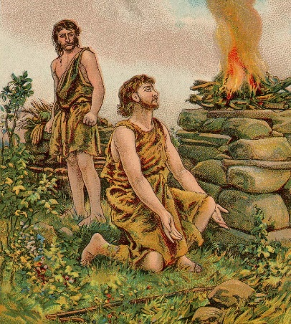
January 10, 2018
Genesis 4:1-17;
25-26
1-1-3
Adam and Eve had two sons. The older one named Cain became a
farmer and grew crops. Abel was a
shepherd. The boys brought offerings to the Lord. The Lord paid attention to Abel when he brought his first born sheep, but for Cain’s offering of the fruit of the ground, He did not pay attention. This made Cain very angry, sad and jealous of his brother, Abel.
God saw Cain’s reaction and asked why he was angry and sad. God told Cain that it was his choice to do well and then he should not be angry nor sad. He reminded Cain if he continued in his anger and not control it, he would sin. Later in the field, Cain rose up and killed Abel.
God knows everything and knew what Cain had done, but confronted Cain and asked him, “Where is your brother, Abel?” Cain replied, “I do not know. Am I my brother’s keeper?” God had to punish Cain for his sin and cursed the ground, so when he farmed, no crops would grow and he would be a wanderer with no home or a regular job. Cain thought someone would kill him, so the Lord protected Cain by putting a mark on him so if anyone disobey the mark and harmed Cain, they would receive seven times the punishment that was dealt to Cain.
After Abel’s death and Cain left Adam and Eve, they had another child by the name of Seth.

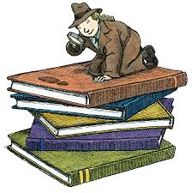
Questions: Find the facts

- What were Cain & Abel’s jobs?

- What were their offerings?

- Why was Cain angry with Abel?

- What were the things that led up to Cain’s sin?

- Explain Cain’s excuse, “Am I my brother’s keeper?”

- What was Cain’s punishment for murdering his brother?

- How did God protect Cain even though he was cursed?

- Adam and Eve lost one son to death and one left God’s presence. Did they have any other children?

Thought Questions:
(Bring your thoughts to class or write on the back of the page.)
The idea of “free will” is introduced in this story. What
does free will mean and which verse talks about it?
Psalms 4:4 says “Be angry and do not sin.” How is it possible to be angry without sinning?

From Old Testament to New Testament
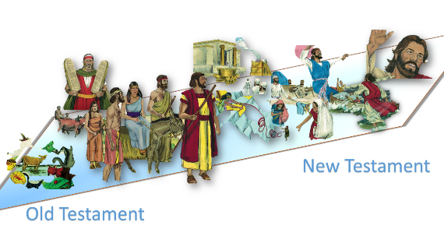

●The story of Cain & Abel doesn’t say why Abel’s sacrifice was accepted by God. However, Hebrews 11:-1-4 tells us. Why?

● I John 3:12-15 says Cain is wicked and a murderer. We know that is true. We know murdering is a horrible sin. What does v. 15 say is equal to murder?

●Luke 3:23-38 gives Christ’s genealogy. Can you find names you recognize? Which one of Adam’s sons do you see?

