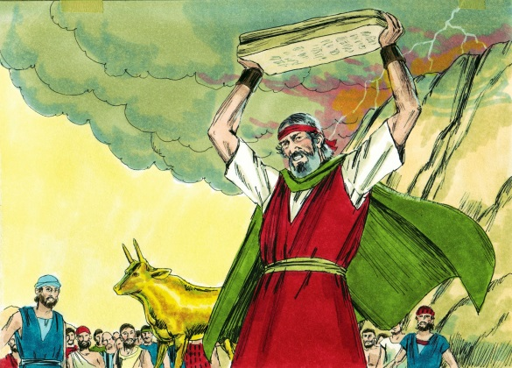
ISRAEL CREATES THE
GOLDEN CALF
Exodus
32-34
April 15, 2018
1-1-29

Moses was on Mt. Sinai a
long time receiving the Ten Commandments. The people of Israel became very impatient and told Aaron to make a god for them since they didn’t know what had happened to Moses.
Aaron agreed to this and he asked the people to give him their gold earrings. Aaron melted down the gold and shaped the gold into a calf. He told the Israelites, “This is your god, O Israel, who brought you up from the land of Egypt.”
The Lord told Moses what the people were doing and He told Moses to get down the mountain. He said the Israelites were a stubborn people and He wanted to destroy them. Moses pleaded with the Lord to change His mind.
Moses went down the mountain and he saw the calf and the dancing and he became very angry. He threw the tablets he was holding and they shattered. He took the calf and burned it, ground it to powder, scattered the powder over the water, and made the sons of Israel drink it. Then he questioned Aaron about the calf. Aaron said he threw gold from the Israelites into the fire and the calf came out. Then Moses stood in the gate and asked for those for the Lord to come to him. All the sons of Levi came. Moses told them to take their swords and kill all those doing evil. About three thousand men lost their lives.
On the next day, Moses informed the people that they had committed a great sin and that he would go before the Lord and ask the Lord to forgive them. The Lord responded that Moses should continue to lead the people where the Lord told him to and those guilty of worshipping the golden calf would be punished.

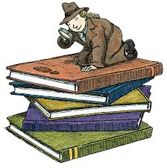
Questions: Find the facts

- Who did the Israelites ask to help them make gods?

- What did they use to make the idol?

- What did the idol look like?

- Do the people still think they are worshipping God? (Hint: look at Ex. 32:4-5 before you answer the question.)

- What does God want to do to punish the people? (Ex. 32:10)

- What is the actual punishment?

- How does Moses change God’s mind about punishing the people? (He has two main reasons.) 1.________________________ 2. _________________________

- Did the people deserve to be punished? Are you glad that God is willing to change his mind?

- What happened to the first set of tablets with the Law written by God?

  - Who wrote the 2nd set of tablets?
  - How long did it take?
- God tells Moses in Exodus 34:11-16 how He is going to fulfill the land promise. What do the children of Israel have to do to make sure they keep the land?

Thought Questions: (Bring your thoughts to class or write on the back of the page.)
The The children of Israel are showing big problems by making an idol. There are many, but name at least two. 1. ________________________________
2. _______________________________
Does it seem like Aaron put up much of an argument to the people’s request to make an idol? Can you think of a reason why?

From Old Testament to New Testament is on the next page
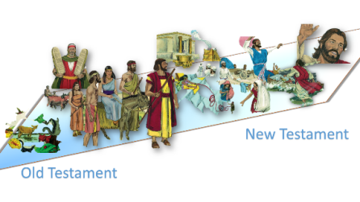
From Old Testament to New Testament

Moses face was shining when he came down from Mount Sinai because he had been in the presence of God. In Exodus 34:33, Moses put a veil over his face and only took it off when he went into talk to God. Paul talks about this veil in 2 Corinthians 3:12-18. He says that we don’t have a veil like Moses because of what? (In other words, why do we understand the Old Testament better than the children of Israel did?)

