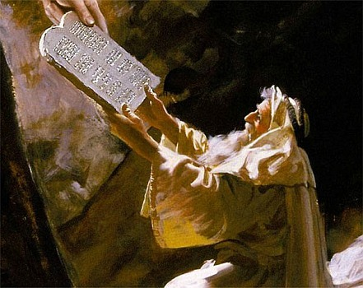THE TEN COMMANDMENTS
April 11, 2018
Exodus
20:1-18, 31:12-18 32:1
1-1-28

During the third month
of the children of Israel’s journey out of bondage and the land of
Egypt, they came to the Wilderness of Sinai. Moses went up to God on the mountain and the Lord told Moses to remind the people how He protected them and brought them safely to this place and to Himself. Moses was to tell them IF they would obey God’s voice and keep His covenant, that they would be His special treasure above everyone else. The people would be to God a kingdom of priests and a holy nation. Moses went back to the people and they washed themselves and their clothes to prepare to meet God.
God called Moses to the top of the mountain and Moses went up. God sent Moses back down to warn the people not to touch Mount Sinai or try to gaze upon the Lord or they would die. The Lord gave Moses the words of the ten commandments (Ex 20:1-17) to teach the people and He told Moses to come back up the mountain and He would give Moses tablets of stone with the law and commandments written on them.
Moses went up to accept the tablets and God gave Moses specific instructions regarding how to treat and worship on the Sabbath. Moses was on the mountain for 40 days and 40 nights and the children of Israel began to wonder what became of him.

Questions: Find the facts
- What did the Lord want to create with the people?

- What did the Lord want the people to do?

- Were the people to try and see the Lord for themselves?

- List the Ten Commandments without looking…
1.___________________ 2. ___________________ 3._____________________

4.___________________ 5. ___________________ 6._____________________

7. ___________________8.____________________ 9._____________________

10. _________________

- The first four Commandments were the people’s relationship with whom?

- The last six Commandments were how the people should treat whom?

- How long was Moses on the mountain? (Ex. 24:18)

- In the last several chapters of our reading, God gave Moses specific instructions for what?

Thought Questions: (Bring your thoughts to class or write on the back of the page.)
The 1. Read Titus 2:11-14. What covenant does God offer to ALL people today?

2. How do WE accept God’s terms? (Acts 2:38-39)

From Old Testament to New Testament
- 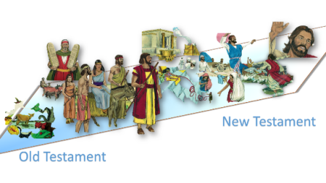Read Exodus 19:10-14. What did God want the Israelites to do to prepare them to draw near to Him?

- Read James 4:8. What is the same for US about approaching God? What is different?

