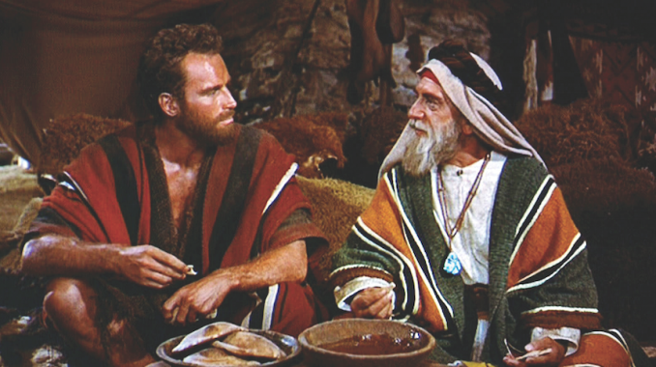
MOSES & JETHRO
April 8, 2018
Exodus
18:1-27
1-1-27

Moses’ father-in-law was Jethro, the priest of Midian. He came to Moses to bring Moses’ wife, Zipporah and their two sons, Gershom and Eliezer to Moses. Moses told Jethro about everything that had happened in Egypt with Pharaoh and how the Lord had led the Israelites out of there. Jethro was very happy to hear all of this and he said, “Now I know that the Lord is greater than all the gods.”
The next day, Moses sat down to judge the people. Jethro told Moses that he was doing a good thing but that he would wear himself out judging all of the people by himself. He advised Moses to appoint men who feared God to help him with this huge task. The men would judge the little disputes and Moses would judge the major disputes. This way Moses would be able to endure.
Moses listened to the advice of his father-in-law and appointed men to help him with solving disputes among the Israelites. Moses’ job became a lot easier.

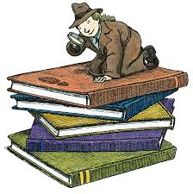
Questions: Find the facts

- Who is Jethro?

- Has Jethro been with Moses and the Hebrews? Who has been with Jethro?

- Why does he come to see Moses?

- Who gets the credit for their deliverance? (Ex. 18:8-9)

- How does God use Jethro to teach Moses?

- Describe the system that he uses.

Thought Questions: (Bring your thoughts to class or write on the back of the page.)
The Before the new judging system goes into effect, Jethro says two things need to be done in verse 20. What are they?
- _______________________________ 2. __________________________________
  - What would happen if we didn’t do these things before we gave people the responsibility of being in charge?
From Old Testament to New Testament
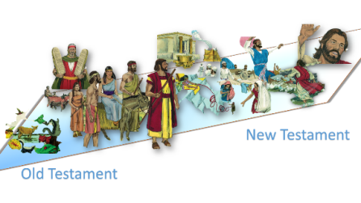
God used organization to help Moses. He separated physical and spiritual issues for different people to judge. Does he do something similar for the church now? (Acts 6:2-3)

