ISRAEL BATTLES

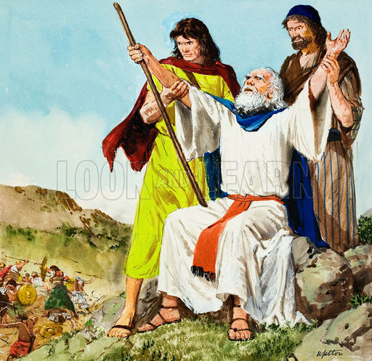

THE AMALEKITES

Exodus

17:1-2, 17:8-16

April 4, 2018

1-1-26

The Lord took care of the

people’s needs again and provides food; manna in the morning and quail in the evening.

According to the commandment of the Lord, they continued their journey and camped in Rephidim, but there was no water. Again the people argue with Moses to give them water! The people are thirsty and complain to Moses and ask him why he brought them out of Egypt to kill them, their families and livestock with thirst. Moses prays to the Lord for help because the people are ready to kill Moses by stoning him. The Lord tells Moses to take his rod and in sight of everyone, strike the rock in Horeb and water will flow from it. Moses did so and the water flowed. He called the name of the place Massah and Meribah because the children of Israel contended with Moses and tempted the Lord by saying, “Is the Lord among us or not?”

Now the children of Israel were attacked by Amalek in Rephidim. Moses told Joshua to choose some men and go out and fight against Amalek the next day. Moses said he would stand on the top of the hill with the rod of God in his hand. Aaron and Hur went up to the top of the hill with Moses the next day. When Moses held his hands up, Israel would win, but when he let down his hands, Amalek would win. Moses’ hands became heavy, so Aaron and Hur sat Moses on a stone and they supported his hands, one on each side of him to keep his hands steady until the sun set. Because of this, Joshua defeated Amalek and his people with the edge of the sword. God was angry that Amalek found against the Israelites and told Moses to write it down that the Lord would have war with Amalek for generation to generation and will utterly blot out any remembrance of Amalek from under heaven. After the battle, Moses build an altar and called its name, The-Lord-Is-My-Banner.

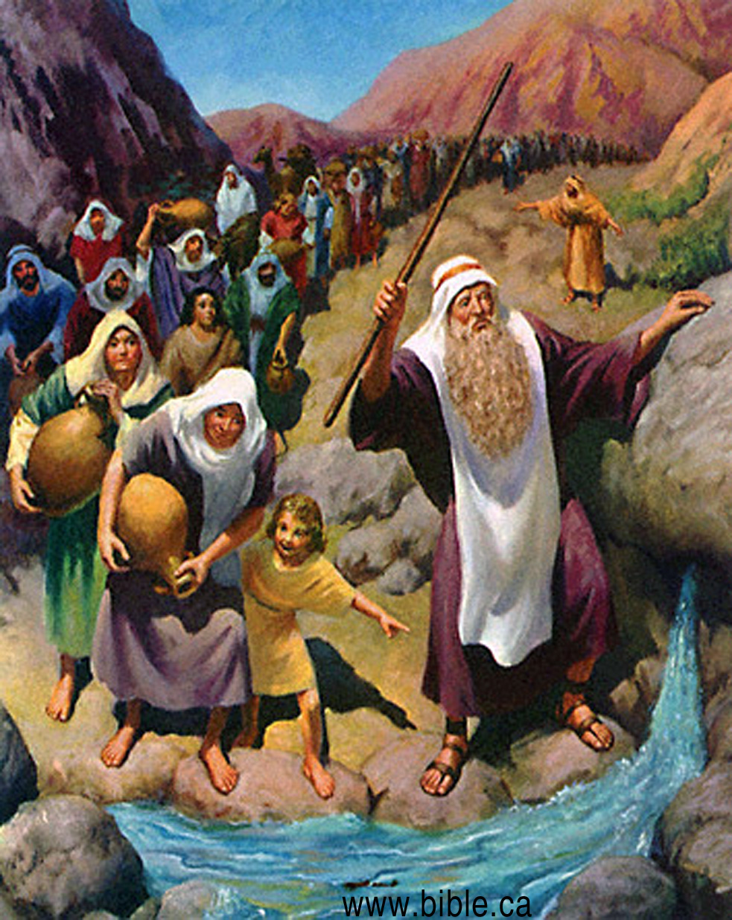

**Questions: Find the facts**



1. Why were the people complaining to Moses again? What did Moses mean when he asked the people, “Why do you tempt the Lord?” (Ex. 17:1-2)
2. What new person do we meet in 17:9?
3. Who were the Israelites to do battle with?
4. Who stood on top of the hill?
5. What happened to Moses arms?
6. What did they do to remedy the problem?
7. How long were Moses arms steady?
8. Who won the battle?
9. What did the Lord promise in regard to His dealings with Amalek?
10. What did Moses do on the hill?

**Thought Questions:** (Bring your thoughts to class or write on the back of the page.)



The When the people were complaining to God about the water it shows God’s continued mercy. If you were God, how would you react to the people’s constant complaining? What does this show us about God?

**From Old Testament to New Testament**

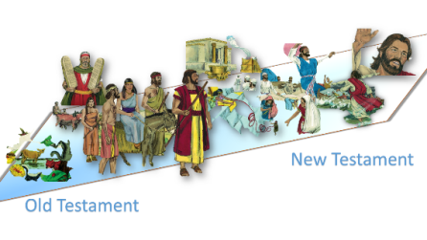

Aaron and Hur helped Moses to keep his arms steady and comfortable in order for Moses to do what God wanted him to do. How does our Christian family help us to continue to do what God says?