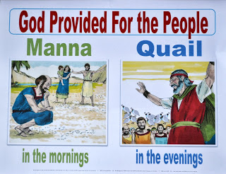
GOD PROVIDES FOOD
1st SABBATH
Exodus
16-17:7
April 1, 2018
1-1-25

The Israelites travelled to the Wilderness of Sin and the whole group complained to Moses about being hungry. They said they had been better off in Egypt where they had food to eat. The Lord heard their grumbling and he told Moses He would rain bread from heaven down to the camp. The people were to go out and gather a day’s portion every day. On the sixth day, though, they would gather a double portion because on the Sabbath, the seventh day, there would be no bread to gather. The Lord also provided meat. Quails would come and cover the camp in the evening.
The people were not to have any leftovers on days 1-5. Some did not listen and they kept leftovers for the next day. The leftovers became full of worms so the people learned to do what they were told. On the sixth day, they were told to gather twice as much. Moses explained to them that the seventh day was a holy day to the Lord. The people were to rest and not boil or bake anything to eat. The leftovers from the sixth day would not get worms in it or turn foul.
On the very first Sabbath, some of the congregation did not follow instructions given to them by the Lord. They tried to gather bread in the morning, but there wasn’t any. The Israelites learned that God meant what He said and it was very important that they follow his instructions.
The people of Israel named the bread manna. God commanded that Moses collect a jarful of manna to be kept for the generations to come so that they could see that the Lord had taken care of them and fed them when He brought them out of the land of Egypt.
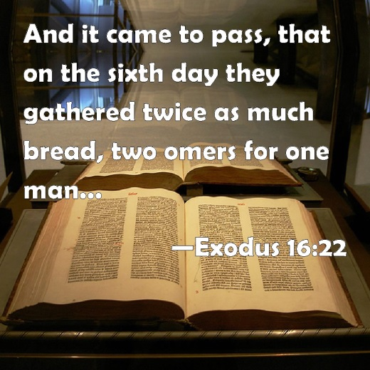
Questions: Find the facts

- At the beginning of Exodus 16, the children of Israel are doing what? How did God fix their issue?

- How long were the Israelites to keep the bread? Did they all listen to Moses’ advice?

- What was the bread rule for the Sabbath day? Did they all do what Moses told them to do?

- What did the Lord want Moses and Aaron to do? (Ex. 16:31-34)

- How long did the Israelites eat the manna and quail?

- What did God prove to the Israelites AGAIN when He brought the manna and the quail?

- Why did God want Moses and Aaron to save a portion of the manna?

Thought Questions: (Bring your thoughts to class or write on the back of the page.)
The At the beginning of the reading, Israel is signing the Lord’s praises, but at the end of our text they were begging to go back to Egypt. What changed? How are you like the Israelites…when does your faith waver?
What c

From Old Testament to New Testament
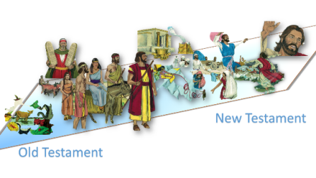
The Israelites constantly chose NOT to follow God’s commandments and they faced consequences. God tells us today that we must obey His commandments to be pleasing to Him. What types of commandments do people want to ignore?

