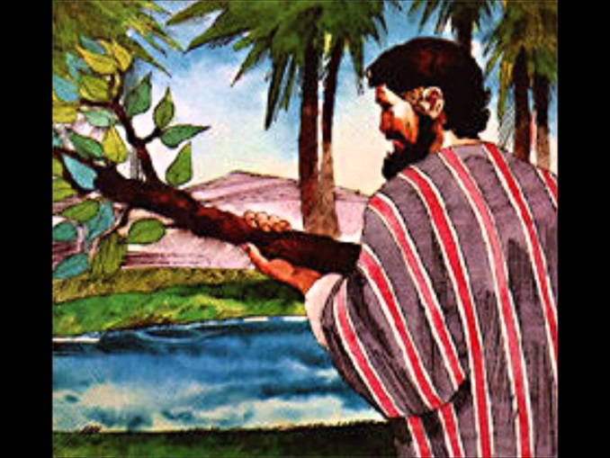
GOD PROVIDES WATER
March 28, 2018
Exodus
15:22-27
1-1-24

The Lord had just
saved the Israelites from
the hands of the Egyptians by
drowning them in the Red Sea so they could not follow them. Israel saw the great works the Lord had done, so the people feared the Lord and believed the Lord and His servant Moses.
Now Moses and the children of Israel sang a song praising God for his strength, announcing that He is their God, exalting Him and proclaiming all the inhabitants of Canaan will fear God because of His greatness and power. Their song recounts what they just witnessed and announce the Lord shall reign forever and ever for He has triumphed gloriously! Miriam and all the women answered them: “Sing to the Lord, For He has triumphed gloriously! The horse and its rider He has thrown into the sea!”
Moses then led the children of Israel from the Red Sea to the Wilderness of Shur and they journeyed three days without finding water. When they came to Marah, the water was bitter and they could not drink it. The people complained against Moses and wanted to know what they would drink. So, Moses cried to the Lord and the Lord showed him a tree to cast into the water and when he did the water was made sweet.
Right there at that spot, God tested the people and made an ordinance for them to follow. God said, “If you diligently heed the voice of the Lord your God and do what is right in His sight, give ear to His commandments and keep all His statues, I will put none of the diseases on you which I have brought on the Egyptians. For I am the Lord who heals you.”
Remember the people just three days ago saw the Lord God’s mighty power and were singing praises to Him for saving them and freeing them from Egyptian bondage. Now they are complaining. The Lord is reminding them if they trust Him and obey Him, He will protect them.
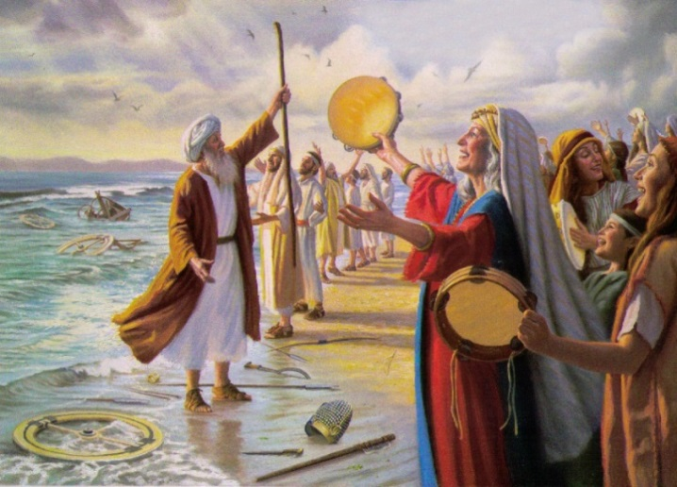
The Israelites, all 600,000 (Ex. 12:37) plus, travel on and come to Elim and wonderful place with twelve wells of water and seventy palm trees and they camped there. God provides in abundance for them on their journey to Canaan the land God promised Abraham so many years ago.

Questions: Find the facts

- Exodus 15 is a song of praise to God for deliverance from what event?
- What are some of the feelings Moses expresses in his song? (Ex. 15:1-19)

- In Exodus 15:14-17, what are the Israelites praising God for?

- How long did the Israelites wander without finding water?

- What was their first response when they had a difficult time?

- What does this tell you about their faith?

- What does God say the Israelites need to do in order to be protected by Him? (Hint: Ex. 15:26)

a.______________ b. _______________ c. ________________ d._______________

Thought Questions: (Bring your thoughts to class or write on the back of the page.)
The Is faith easier during good times? How do we help our faith become strong so that when hard times come it remains strong? Think of some examples of when you have complained about not getting what you wanted during a hard time.

From Old Testament to New Testament
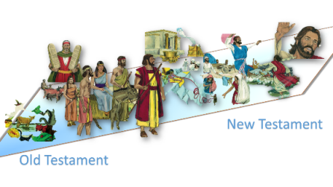
God says in Exodus 15:26 that He will protect His people IF they obey Him. Is this still true in the New Testament? (see Rev. 2:7)

