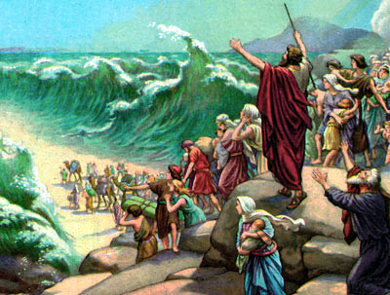
ISRAEL LEAVES EGYPT
Exodus
13:11 thru
14:31
March 25, 2018
1-1-23

After the tenth plague, Pharaoh let the Israelites go.
Finally, they could be on their way to the Promised Land of Canaan.
The Lord was with them guiding them in a pillar of cloud by day and a pillar of fire by night. Instead of taking them through the land of the Philistines which was shorter, God led them by the way of the wilderness to the Red Sea.
In the meantime, Pharaoh had hardened his heart and he went after the Israelites with his army. The Israelites were at the edge of the Red Sea and they saw the Egyptians coming for them. Panic set in and they cried out, “It would have been better for us to serve the Egyptians than to die in the wilderness!”
In response, Moses told them to keep silent and God would fight for them. The pillar of cloud moved to be between the Israelites and the approaching Egyptians. Moses stretched out his hand over the sea and the Lord caused the waters of the sea to be parted. The Israelites crossed the sea on dry ground. Pharaoh’s army followed them. The Lord caused their chariots to swerve and Moses stretched his arm over the sea and the walls of water came crashing down on the whole army. No one remained.
The Lord saved his people! The Israelites witnessed God’s amazing power and now they feared Him and believed in Him.

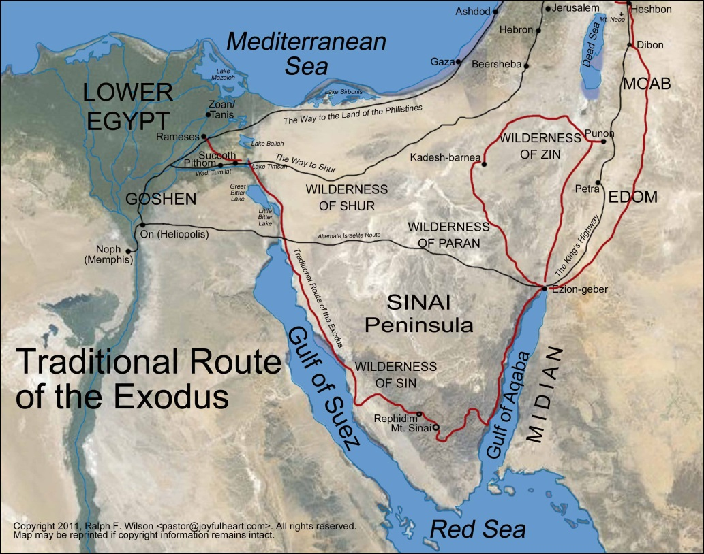

Questions: Find the facts

- Whose bones did Moses remember to take with him?

- What happened to Pharaoh’s heart again after the Hebrews left?

- How long did it take for the Red Sea to part? (Ex. 14:21)

- Mark Egypt, Goshen, the Red Sea, Mt. Sinai, Caanan and Philistia on the map on the next page. Then mark the route of the Israelites with a dashed line. (Use a map in the back of your Bible or your parent’s Bible for help.)

- God led the people out of Egypt through the wilderness of the Red Sea (Ex. 13:17-18) instead of through the land of the Philistines. Which way was shorter?

- Why did God choose the other way?

Thought Questions: (Bring your thoughts to class or write on the back of the page.)
The God stayed with the Hebrews through their journey in the wilderness as a pillar of cloud and pillar of fire. Think of some ways that God is with you now. Do you think God expects more faith from us today since we can’t see the pillar of cloud or fire? Please be ready to explain your answer.

From Old Testament to New Testament
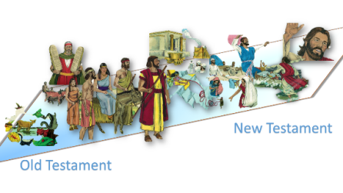
One of the most amazing statements of faith comes from Moses in Ex. 14:13. He says, “Do not be afraid. Stand still, and see the salvation of the Lord.” Why do you think standing still and letting the Lord be in control is hard for us sometimes? Can you think of a NT person who had trouble with this? (Hint: John 18:10-11)

