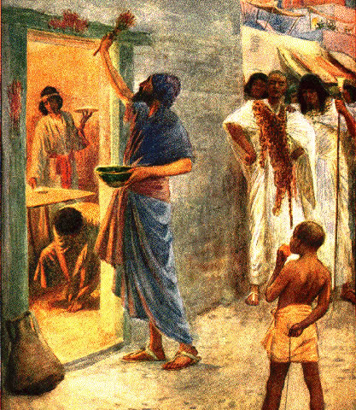THE LAST PLAGUE
Exodus
11, 12:21-41, 13:10
PASSOVER
March 21, 2018
1-1-22

God had one more plague to bring
on Pharaoh and Egypt and after this one he would let Moses and God’s people, the Israelites, go. Each man was to ask his Egyptian neighbor for silver and gold and they willing gave because even Pharaoh’s subjects highly respected Moses. The Lord told Moses to tell Pharaoh around midnight He would go out into the middle of Egypt and all the firstborn in the land of Egypt would die, from the first born of Pharaoh’s house, to the slave girl and livestock too. But no harm would come to the sons of Israel. After Moses gave these words to Pharaoh, Moses left very angry. Pharaoh still hardened his heart.
God had Moses and Aaron prepare His people for the last plague. They were to take a lamb, slay it and put the blood on the two doorposts and lintel (top of the door) and stay inside till morning. They were to roast the lamb with fire, eat it with unleavened bread and bitter herbs and consume it all. Eat it in haste like they need to leave in a hurry, with girded loins, sandals on their feet, and staff in their hand. Moses told the people they would observe this event forever; this day would be a memorial to them and they would celebrate it as a feast to the Lord. They would tell their children about the time when the destroyer passover the door with the blood on it, but for the houses without the blood on it, the Lord would strike the first born and there was a great cry in Egypt.
The destroyer came at midnight and when Pharaoh’s first born died and he heard the crying from all over his kingdom, he called for Moses and Aaron at night and said, “Rise up, get out from among my people, both you and the sons of Israel, go worship the Lord, take your flock and herds and go and bless me also. The people had prepared as Moses instructed and were ready to go. The took their cakes of unleavened baked bread because it didn’t have time to rise. The sons of Israel numbered six hundred thousand men aside from the children. The Israelites had lived in Egypt for 430 years.
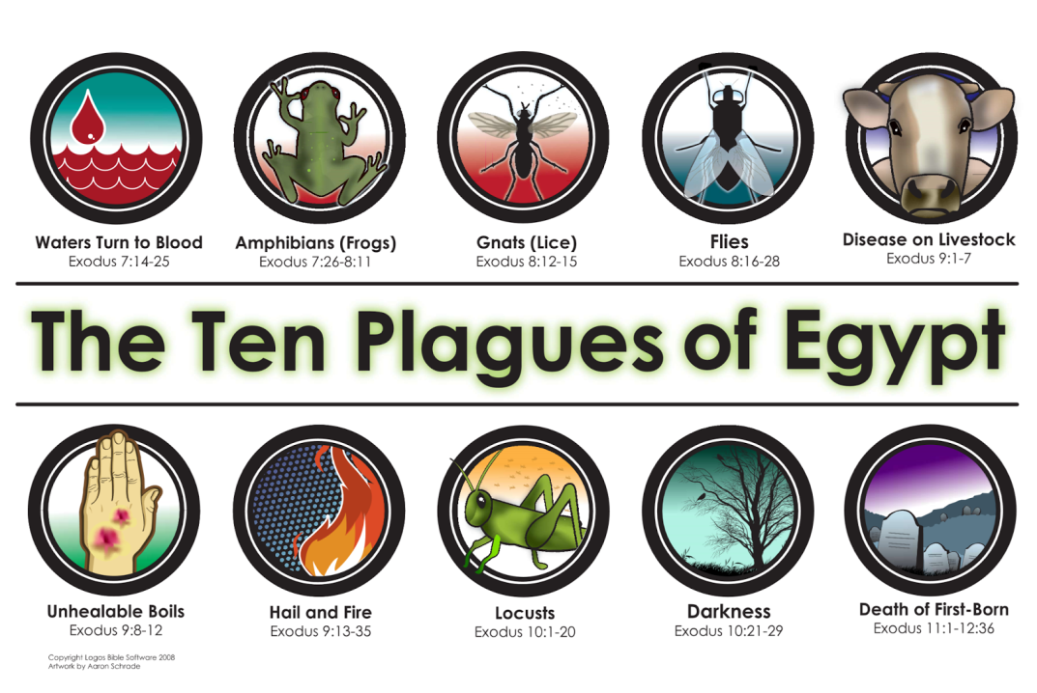

Questions: Find the facts

- How did Moses feel after giving the news of the last plague to Pharaoh?

- On the night of the Passover, what were God’s people to eat?

- What was the Passover to become from this time forward?

- How long was Israel in Egypt?

- Why were the people to only eat unleavened bread?

- In Exodus 12:11 the scriptures say that they were to wear clothing in a specific way. Why?

Thought Questions: (Bring your thoughts to class or write on the back of the page.)
The 1. In Exodus 12:24-27 the Passover was to become a memorial and it was important to tell their children of this event. Why would this have been important to share with their children? What can you compare it to in your life?

From Old Testament to New Testament

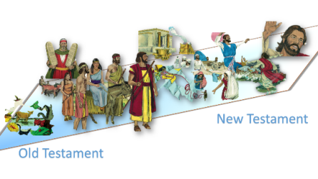What are some ways the Passover Feast is like the Lord’s Supper we celebrate today?

