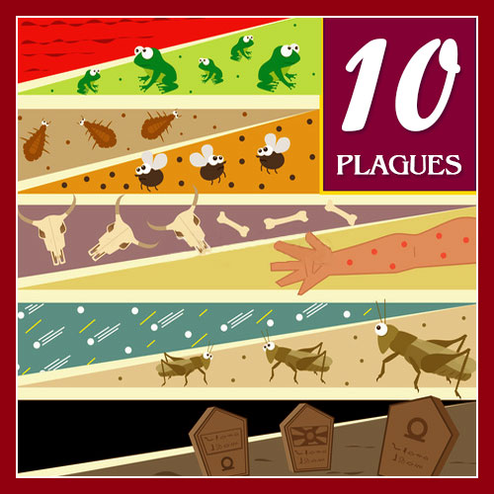
GOD SENDS THE PLAGUES
Exodus
9:8-12, 9:22-35; 10:12-29
(Plagues 6-9)
March 18, 2018
1-1-21

God had sent five plagues on
the Egyptians and still Pharaoh refused
to let the Israelites go. God told Moses and Aaron to take handfuls of ashes and throw them into the sky. The dust became boils and sores on the people and their animals. This was the sixth plague inflicted on the Egyptians yet Pharaoh said no to releasing the Israelites from their bondage.
So God told Moses to stretch out his hand to the sky and that hail such that had never been seen before would fall on man, animals, and every plant and they would die. In the land of Goshen where the Israelites were, there was no hail. This was a very severe plague, so Pharaoh sent for Moses and Aaron and actually admitted this time that he had sinned. Pharaoh asked Moses to ask the Lord to stop the hail and he would let the Israelites go. The Lord stopped the hail but Pharaoh hardened his heart and he refused to let the people go.
Then God sent an eighth plague to the Egyptians. This time locusts came and destroyed everything that was not destroyed by the hail. Pharaoh hardened his heart so the Lord then caused darkness to fall upon the Egyptians for three days. This was the ninth plague. Only the Israelites had light in their homes. Pharaoh called Moses to him and told him that the Israelites could leave to serve the Lord but all of their flocks and herds were to be left behind. Moses let Pharaoh know that this was not acceptable and Pharaoh became really angry. He hardened his heart again and told Moses to get away from him.
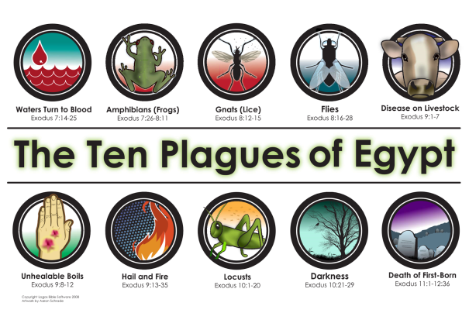
Nine plagues had fallen on Pharaoh and the Egyptians, but they still refused to recognize the power of God. God would send one more plague and all of Egypt would finally know that God is powerful and Lord of all.

Questions: Find the facts

- List the plagues discussed in this lesson:
6. _______________ 7. ______________ 8. ______________ 9. _____________

- Which plague made Paraoh admit that he had sinned? (This is different than just asking God to take away the plague.)

- Who continued to be protected during each of the plagues?

- If you were the Egyptian people, what would you be telling the Israelites?

- With the fourth plague, what was different with the land of Goshen where the Israelites were?

Thought Questions: (Bring your thoughts to class or write on the back of the page.)
The 1. In our last lesson we learned how much God cared about the misery His people were facing. What was Pharaoh’s reaction to the suffering of HIS people? What do YOU learn from that?

From Old Testament to New Testament

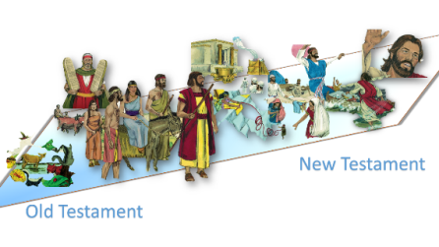
We read about God hardening Pharaoh’s heart in order that His power may be seen (Ex. 10:1-2). How can our hearts be hardened today? (Read Hebrews 3:8 and 13)

