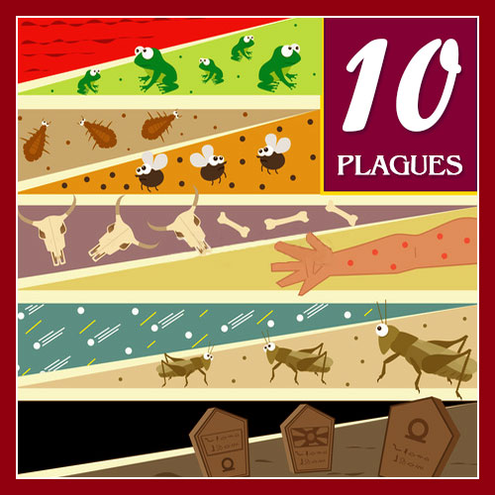GOD SENDS THE PLAGUES
Exodus
7:14-25, 8:1-22, 9:1-7
(Plagues 1-5)
March 14, 2018
1-1-20

Pharaoh’s heart was stubborn
and did not want to let the people go into
the wilderness to worship God. He wanted the people to work hard. God told Moses He was going to strike Egypt with miracles and Pharaoh would let His people go. The first one would turn all water in the desert land of Egypt to blood. All rivers, streams, pools, reservoirs and vessels became blood when Moses and Aaron obeyed God’s command and struck the Nile with the staff. Pharaoh’s magicians were able to do the same thing with their magic arts, so Pharaoh again hardened his heart and the people had to dig around the Nile for water to drink for seven days.
Next, God sent frogs and they covered every inch of the land. In beds, ovens, kneading bowls. Some how the magicians were able with their secret arts make frogs appear too. But this time Pharaoh asked Moses and Aaron to ask the Lord to remove the frogs. When God made them die, Pharaoh broke his promise and did not let the people go as he said.
Then God sent gnats (lice) and they covered every man and beast and the magicians could not duplicate this plague and told Pharaoh, “This is the finger of God.” But, Pharaoh’s heart was still hard. This plague was followed by swarms of flies, but God protected the land of Goshen where his people dwelled to show Pharaoh that the Lord was with His people. Flies covered everything. Pharaoh said they could worship, but not go far and to ask God to remove the flies. Got removed the flies and once again when the plague was removed, he did not let the people go.
The fifth plaque struck and killed all the Egyptian livestock; cattle, horses, donkeys, camels, herds and flocks, but no livestock belonging to the sons of Israel was harmed. Pharaoh’s heart was still hard even though he saw the Lord protected the Israelites’ livestock. 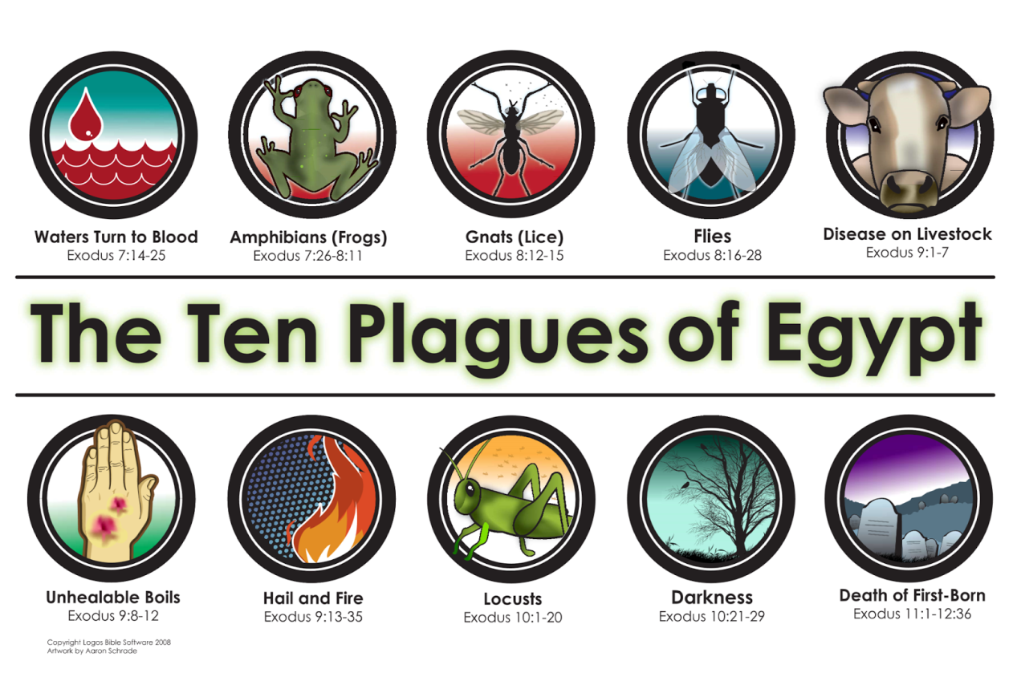

Questions: Find the facts

- What type of climate is Egypt? Why would turning water in the Nile River be such a plague for the people? Couldn’t they get water at another river?

- What did the Egyptians have to do to get water?

- When did Pharaoh change his mind about letting the people go to worship God? (Ex 8:15)

- What was different with the third plague than from the first two plagues? (Ex. 8:19)

- With the fourth plague, what was different with the land of Goshen where the Israelites were?

- Name the first five plagues: 1. _______________ 2. ______________ 3. ______________ 4. ________________ 5. _________________

Thought Questions: (Bring your thoughts to class or write on the back of the page.)
The 1. God takes away each plague at Pharaoh’s request, even after he lies over and over about letting the Hebrews leave. What does this tell us about God’s ability to forgive and his wish for all men to repent?

From Old Testament to New Testament
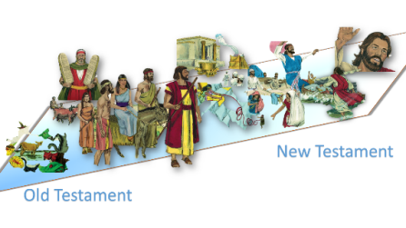 While Pharaoh was suffering hardship, he constantly promised Moses and Aaron that he would let the people go to worship God. When relief came, he went back on his word. How are we like Pharaoh in our commitment to serving God? (Acts 24:24-25)

