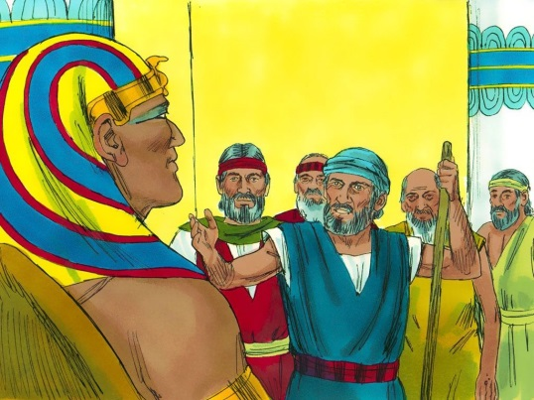
MOSES & PHARAOH
Exodus
4:1-23, 4:29-5:9, 6:5-8
March 11, 2018
1-1-19

God had chosen Moses to lead the Israelites out of Egypt to the promised land of Canaan.
Moses took his brother Aaron and they went to Pharaoh to ask him to let the children of Israel go to worship the Lord. Pharaoh said he did not know the Lord and he denied the request. Pharaoh then increased the work load of the Israelites and he would have them beaten if they did not make enough bricks.
Again, the Lord told Moses and Aaron to go to Pharaoh and ask him to let the Israelites go. God said he would harden Pharaoh’s heart and multiply His signs and wonders so that the Egyptians would know that He was Lord. When Moses and Aaron went to Pharaoh, Aaron threw down his rod and it became a serpent. This was a sign to Pharaoh that they were speaking for God. Pharaoh called for his magicians to do the same thing. They threw down their rods and they became snakes. Even though Aaron’s rod swallowed up the magicians’ rods, Pharaoh hardened his heart and would not let the Israelites go.
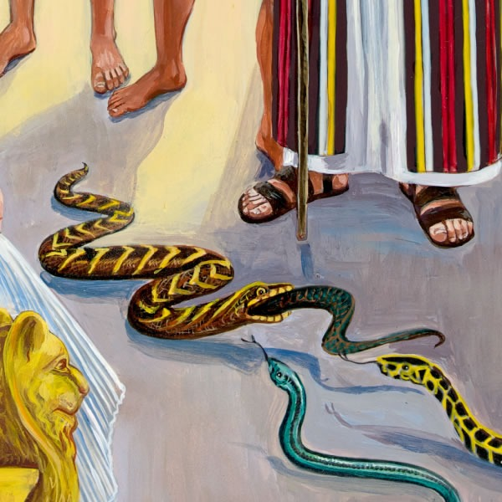

Questions: Find the facts

- What did the Lord do for Moses so he would not doubt?

- Before going to meet Pharaoh, who did Moses and Aaron convince?

- After Moses and Aaron visited Pharaoh for the first time, what was the outcome of the meeting? (Ex. 5)

- When Moses went to the people, why did they not want to listen to him this time? (Ex. 5:21)

- Why was Moses not feeling confident in 6:30?

- In addition to letting His people go, what else did God want the people of Egpyt to know? (Ex. 7:5)

Thought Questions: (Bring your thoughts to class or write on the back of the page.)
The 1. Moses wanted the Lord to send someone else to talk with Pharaoh. How are WE sometimes like Moses in this way?

2. When the people saw that God cared about their misery it made them want to worship God. Does God care what misery and suffering you face? Can you find a bible verse about this? Ask your parents for help if you need to.

From Old Testament to New Testament
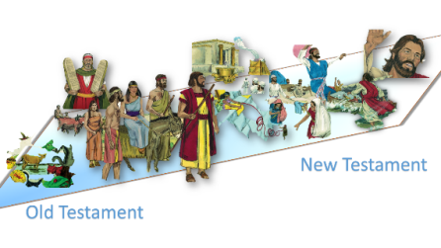
Pharaoh’s heart was hard toward God. We are not immune to the same “heart” problem that Pharaoh suffered. Matthew 13:3-23 talks about the hearts of all people. What traps does Jesus warn us about that can cause our hearts to be in trouble?

