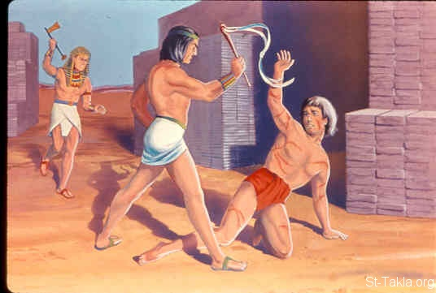 MOSES &
THE BURNING BUSH
Exodus
2:11-3:22
March 7, 2018
1-1-18

Moses grew up as the son of
Pharaoh’s daughter, but he always knew he was a Hebrew.
One day Moses went out and saw how cruel and hard his brothers
had to work. He saw an Egyptian taskmaster beating a Hebrew. When he thought no one was looking, he killed the Egyptian and hid him in the sand. But someone had seen and Moses became afraid. When Pharaoh heard Moses had killed an Egyptian, he tried to have Moses killed, but Moses fled to Midian.
While Moses was in Midian, the king of Egypt died and the sons of Israel were discouraged because of their bondage. They cried for help to God. God heard their groaning; and God remembered his covenant with Abraham, Isaac and Jacob. God saw the sons of Israel and God took notice of them.
When Moses arrived in Midian he sat by a well and helped some shepherdesses water their sheep after shepherds bullied them, married Zipporah, one of Reuel’s daughters, had a son named Gershom whose name means sojourner (traveler) in a foreign land and dwelled with the family of Reuel, priest of Midian (also called Jethro).
One day Moses was pasturing the flocks of his father-in-law and came to Horeb, the mountain of God. The angel of the Lord appeared to him in a blazing fire from the middle of a bush. Moses could not believe the bush was not being consumed and was going to get a closer look. God called to Moses by name, “Moses, Moses! Moses said, “Here I am”. The Lord God told him to not come near, remove his sandals because he was standing on holy ground and that he was the God of Abraham, the God of Isaac, and the God of Jacob.” Moses was afraid and he hid his face from God.
The Lord said He had seen the suffering of His people in Egypt and selected Moses to go to Pharaoh to bring His people, the sons of Israel, out of Egypt and back to the promised land flowing with milk and honey.
God wanted Moses to go and gather the elders of Israel together, tell the “I AM” the God of Abraham, Isaac and Jacob is concerned about you and has seen your trouble in Egypt and will bring you out of the hard slavery back to the promised land. God didn’t say it was going to be easy and promised to strike Egypt with miracles and then Pharaoh would let God’s people go.

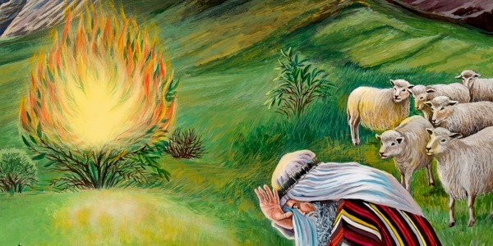

Questions: Find the facts

- Why did Moses kill the Egyptian?

- What did he do afterward?

- What was happening to the Hebrew people because of their hard life of slavery? (Hint: you will find their attitude in Exodus 2:14)

- Had they forgotten about God? (Ex. 2:23)

- What were God’s two reasons for appearing to Moses in the burning bush?

- What were a few things that were miraculous about the burning bush?

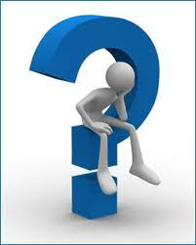 Thought Questions: (Bring your thoughts to class or write on the back of the page.)
The 1. How do you think that Moses knew he was a Hebrew in Exodus 2:11?

2. Moses hid his actions when he buried the Egyptian. What does this say about his conscience? Did he defend his people in a godly way?

From Old Testament to New Testament
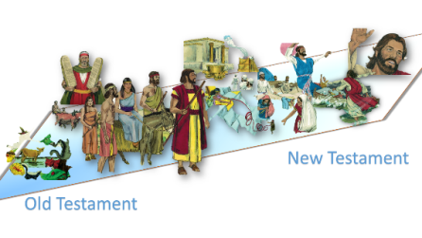 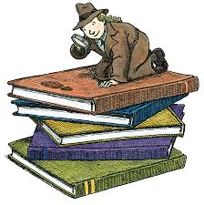Moses’ attitude and actions become very important in the telling of the story of Jesus. Stephen spends a lot of time talking about Moses in his sermon (Acts 7:20-44). List a few qualities that are important in Moses and in us from verses 23-35 in Acts 7.

a.________________________
b.________________________
c.________________________

