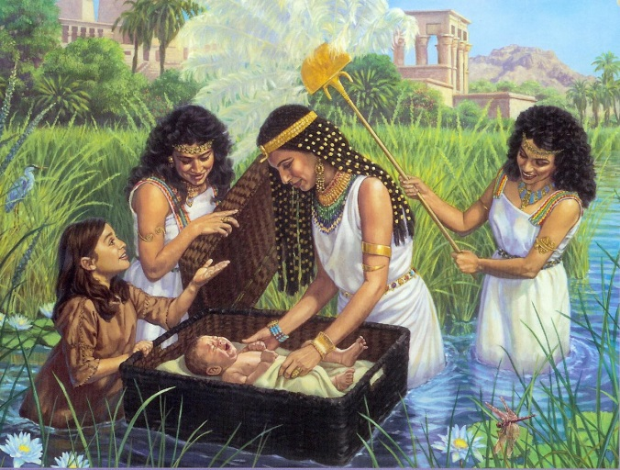
BABY MOSES
March 4, 2018
Exodus
1-2:10
1-1-17

After Joseph died, the Israelite nation living in the
land of Egypt grew in number. The new king of Egypt did not know about Joseph and he was afraid that the Israelites were becoming more powerful than the Egyptians. So the new king made the Israelites slaves and he forced them to build storage cities in Egypt.
However, the more the Israelites were mistreated, the greater they multiplied in number. Pharaoh spoke to the Egyptian midwives that helped the Israelite women deliver their babies and he ordered them to kill the boy babies that were delivered. The midwives feared God so they disobeyed Pharaoh’s orders. Then Pharaoh told all of his people that the Israelite baby boys were to be thrown into the Nile River.
During this time, a baby boy was born to an Israelite woman named Jochebed. She hid him for three months then she made a basket that would float on the Nile River and she put him in it. The baby’s sister Miriam watched over him from a distance. Pharaoh’s daughter came down to the Nile to bathe and she discovered the basket with the baby inside. She knew the baby was an Israelite but she had pity on him and decided he would become her son. Miriam who was watching asked if she could find someone to nurse the baby.
Pharaoh’s daughter said yes to her so she ran and got her mother. Because Pharaoh’s daughter drew the baby out of the water, she named him Moses.

Questions: Find the facts

- How many people of Israel come into Egypt?

- After all the sons of Jacob died, what happened to the descendants?

- Did the new Pharaoh know about Joseph? What scared the new king about Israel?

- Did the oppression of the Israelites do what Pharaoh had intended it to do?

- What did th eKing command of the midwives? Did they listen? How did God look upon the midwives?

- How did Pharaoh try and get around the midwives? (Exodus 1:22)

- Who stood watch over the infant Moses?

- How did Pharaoh’s daughter feel about the child?

- Where did Moses stay until he was weaned?

Thought Questions: (Bring your thoughts to class or write on the back of the page.)
The 1. The midwives were very courageous and stood against Pharaoh’s instance to kill the infants. What could have happened to these women? Do you think it was hard for them to be courageous?

2. Pharaoh’s daughter was a ____________ (hint: a name for royalty). Based on that answer, Moses was a _____________ (hint: a name for royalty) and could have become __________ when he was older. Discuss how God had a better plan for Moses than if he stayed in Egypt.

From Old Testament to New Testament
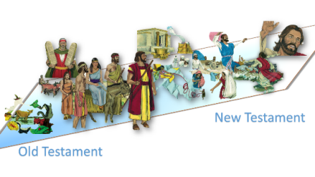
Despite the oppression that the Israelites had on them, they still grew in number. How does this same principle apply to us? (Acts 8:1-4)

