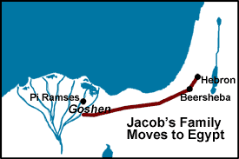 JACOB’S FAMILY MOVES
Genesis
45:16-47:31 & 48, 49:29-33, 50:22-26
TO EGYPT
February 28, 2018
1-1-16

Pharaoh was pleased with
Joseph’s work and loyalty and happy that he was reunited with his brothers, but Pharaoh didn’t stop there. He ordered Joseph to invite
his family to come and live in the best land of Egypt. He sent the brothers back with wagons and pack animals to bring his father and all his father’s family and possession back to live in Goshen.
The brothers go back and tell Jacob that Joseph is not only alive, but the ruler over all Egypt. Jacob is stunned and didn’t believe them. When he say the wagons, animals and supplies returning with them, he believed and looked forward to seeing his son again before he died.
On the way to Egypt, God spoke to Israel (Jacob) in a vision and said, “I am the God of your father; do not be afraid to go down to Egypt, for I will make you a great nation there. I will go down with you to Egypt, and I will also surely bring you up again; and Joseph will close your eyes.”
All Jacobs, sons, daughters, grandsons and granddaughter traveled to Egypt and they numbered seventy. Joseph prepared his chariot and went to meet his father; as soon as he appeared, Joseph fell and wept on him. Joseph told Pharoah that his family was shepherd and the land of Goshen was well-watered to raise livestock. Egyptians looked down on shepherds and would not go near them, so Joseph’s plan to separate his father’s people from the idolatry of the Egyptians was also God’s plan.
Jacob was close to dying, so Joseph brought his two sons, Manasseh and Ephraim to Jacob to bless them. Jacob gave the greater blessing to the younger son, Ephraim because he said the younger brother shall be greater than the older and his descendants shall become a multitude of nations. Israel said to Joseph, “God will be with you and bring you back to the land of your fathers and I give you one portion more than your brothers.” Jacob dies and is embalmed as an Egyptian and taken back to Canaan to be buried in the cave of the field of Machpelah that Abraham bought to bury Sarah and the other patriarchs and their wives.
Joseph holds no grudge against his brothers although his brothers think Joseph will take revenge now that their father is dead. Joseph tells his brothers, “Do not be afraid, for am I in God’s place to judge you? You meant evil against me, but God meant it for good.” God had a plan to protect the Israelites from the famine and bring about a great nation. God is keeping his promise.
Joseph saw his great grandchildren and lived one hundred and ten years. On his deathbed, he reminded and promised them that God would take care of them and bring them up from the land of Egypt and back to Canaan as he promised Abraham, Isaac and Jacob. He requested them to carry his bones back home when God took them back.

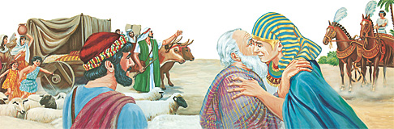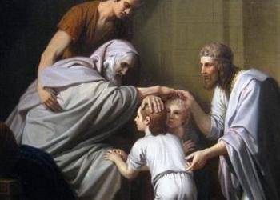
Questions: Find the facts

- How does Pharaoh repay Joseph for all his work?

- What does Jacob think when he hears that Joseph is still alive?

- How many people went with Jacob to Egypt? (Gen. 46:26-27)

- Have we reached the “great nation” promise yet?

- Who did Jacob bless greater, Ephraim or Manasseh? Why?

- Who was Jacob buried with after he died? (Gen. 49:29-31) Why did God appear to Jacob in Genesis. 46:1-4?

- List a few things that Jacob thinks were important in his life. (Gen. 48:1-7)

- What did Joseph promise on his deathbed? (Gen. 50:24-25)

Thought Questions: (Bring your thoughts to class or write on the back of the page.)
- Joseph still wants his family to live a little separate from the Egyptians in the land of Goshen. He uses the truth about his brothers being shepherds to get this land. (Gen. 46: 31-34) Why do you think he wants them there?

From Old Testament to New Testament
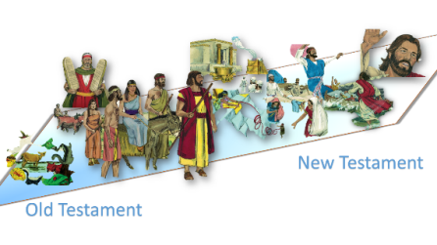 We have seen several examples of younger/weaker brothers receiving a greater blessing. Jesus talks about rewards going to those who find God’s grace rather than a reward going to those who think they deserve them. Read Matthew 19:29-30

