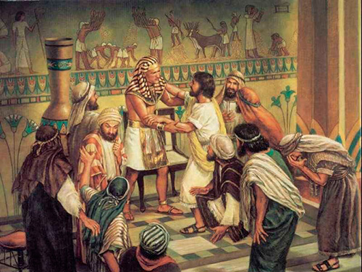
JOSEPH FORGIVES HIS
Genesis 41:46 thru 45:15
BROTHERS
February 25, 2018
1-1-15

Jacob and his family were hungry because of the famine.
The land of Egypt had food so Jacob sent all of his sons except Benjamin to Egypt to get some. When the brothers got to Egypt they did not recognize Joseph. They bowed before him just like in Joseph’s dream many years before! Joseph sold them food but decided to test his brothers. He kept Simeon and said that they must bring Benjamin to Egypt.
At first, Jacob would not let Benjamin go to Egypt, but he changed his mind when they ran out of food and the brothers found it necessary to go to Egypt for more food. When the brothers got to Egypt, Joseph had a feast for them. When he saw Benjamin, he left the room and wept. The brothers still did not recognize Joseph.
Joseph had the brothers’ bags filled with grain and he hid his silver cup in Benjamin’s bag before his brothers left to return to Jacob. Joseph sent his servant after the group and the servant found the silver cup in Benjamin’s bag. The brothers were brought back to Joseph who said that the one who had the cup had to be Joseph’s slave. Judah begged to be the slave instead and that is when Joseph could keep his secret no longer. He told his brothers who he was and he forgave them. He said God meant all that had happened for good. Because Joseph was in Egypt and in such a powerful position, he was able to save his family from starving during the famine.

Questions: Find the facts

- Did Pharaoh’s dream come true just as Joseph said it would?

- Was there famine just in Egypt? Where did the people get their food?

- Did the brothers recognize Joseph? Did Joseph recognize the brothers?

- Why did he accuse the brothers of being spies?

- What deal did Joseph make with the brothers?

- What else did Jacob suggest the brothers take with them back to Egypt?

- As the brothers dined at Joseph’s house, how much more did Benjamin get than the other brothers?

- How did Joseph keep the brothers from leaving Egypt?

- How did Joseph and the brothers feel when they were finally reunited?

Thought Questions: (Bring your thoughts to class or write on the back of the page.)
- Explain how Joseph’s dreams of his youth were fulfilled in our text today.

- What one trait did Joseph possess that his father impressed upon him at an early age? Was this a good trait to have or a bad trait? (Genesis 43:34)

From Old Testament to New Testament
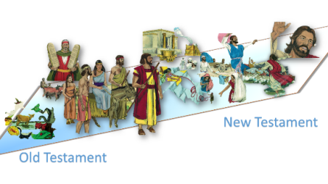
The story of Joseph and the reuniting with his brothers is an excellent example to us of forgiveness. How can we use this example as we deal with people in our lives? (Eph. 4:32)

