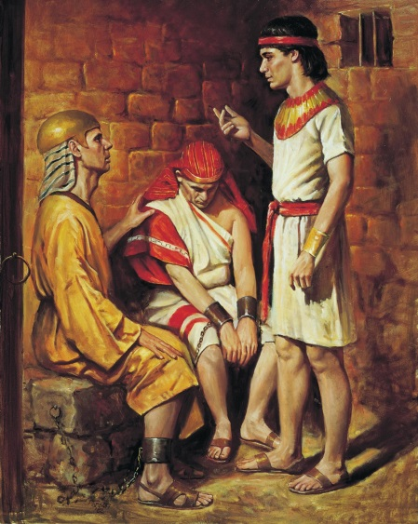 JOSEPH IN PRISON
Genesis 39:1 thru 41:45
February 21, 2018
1-1-14

Joseph was sold to the Ishmaelite traders by his brothers and
taken to Egypt. There he was purchased by Potiphar,
an Egyptian officer of Pharaoh, the captain of the bodyguard. The Lord was with Joseph, so he became a successful man. He worked hard for his master and Potiphar saw how the Lord caused all that Joseph did to prosper in his hand, so Joseph became Potiphar’s personal servant and overseer over his house. The Lord blessed the Egyptian’s home because of Joseph.
Now Joseph was very handsome and had strong leadership skills. The master’s wife began to notice Joseph and wanted him to act like her husband, but she already had a husband, Potiphar. Joseph knew that his master trusted him and it was a sin to act like a husband to another man’s wife, so he told her, NO! Joseph would not sin against God, but she did not listen and one day she lied and told her husband Joseph tried to attack her, she screamed and he ran away. Potiphar believed his wife and threw Joseph in jail. Joseph did the right thing and had fled from sin.
While in prison, the Lord was with Joseph and gave him favor in the sight of the chief jailer. The jailer trusted Joseph and put him in charge of all the prisoners. Whatever Joseph did in prison, the Lord made prosper.
Joseph was put in charge of caring for the King’s cupbearer and baker who were thrown into prison for offending the king of Egypt. One night they each had a dream and in the morning Joseph noticed they were sad and asked why. They could not understand their dreams, so Joseph said God would help him interpret the cupbearer’s dream. (see Gen. 9:9-19 for dream details) Joseph told the cupbearer that within three days Pharaoh’s would restore him to his position. The baker did not have a favorable interpretation and would be hung in three days. Thus in three days everything came about just as Joseph had interpreted. Joseph had asked the cupbearer to remember him to Pharaoh and to get him out of the jail for he was kidnapped and had done nothing to be put in the dungeon, but the cupbearer forgot about Joseph’s request.
Now Pharaoh had a dream after Joseph had been in prison for two full years. Pharaoh’s spirit was troubled and none of his magicians could interpret his dream. (see Gen. 41:1-32 for dream details) The cupbearer remembered Joseph and told Pharaoh about his experience in prison when Joseph interpreted his dream. Joseph was quickly brought to Pharaoh and gave credit to God for providing the interpretation saying, “It is not in me; God will give Pharaoh a favorable answer.” The dream warned of a coming famine that would last seven years, but before that would be seven years of abundance so they could prepare. God supplied Joseph with an action plan to prepare for the famine and he presented it to Pharaoh. Pharaoh saw the Lord was with Joseph and appointed him 2nd in command, gave him his own signet ring, clothed him in find garments, put a gold necklace around his neck, gave him his daughter as a wife. Joseph was thirty years old when Pharaoh gave Joseph command of Egypt.

Questions: Find the facts

- Once in Egypt, where was Joseph taken?

- Who was with Joseph? What was the result of this?

- How would you describe Joseph’s work ethic?

- Who wanted Joseph to sin?

- Who did Joseph meet while in prison?

- What did Joseph do for them?

- What was Joseph’s ONLY request while in prison? Did this request come about?

- What did Joseph do for Pharaoh?

- What happened because Joseph interpretated Pharaoh’s dream?

Thought Questions: (Bring your thoughts to class or write on the back of the page.)
- Joseph was willing to leave his cloak behind to get away from sin as fast as he could. What are some attitudes or activities that YOU might need to leave behind (as a 2nd or 3rd grader) to get away from sin?

- Genesis 41:38-39 says that Pharaoh could tell that Joseph was guided by God. How do YOU show others that YOU love and obey and are guided by God’s Word?

From Old Testament to New Testament
Joseph continually set a good example for people older than him. In what ways can young people set a good example? (I Timothy 4:12)

