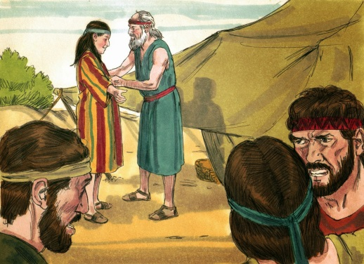
JOSEPH & HIS BROTHERS February, 18, 2018
Genesis 37
1-1-13

Jacob lived in the land of Canaan with his wives and his twelve sons.
His favorite son was Joseph because he was the son of the wife he loved the most, Rachel, and he gave Joseph a special coat of many colors. Joseph’s brothers knew Jacob loved Joseph the most and they hated him for it.
One day, Joseph had a dream and he told it to his brothers. Joseph said they were all working in a field of grain together. Each of them had a sheaf of grain. Joseph’s sheaf stood upright in the field while the sheaves of the brothers bowed down before Joseph’s sheaf. They asked Joseph if he really thought that one day he would rule over them. They hated Joseph even more.
Then Joseph had another dream. In this dream, the sun, moon and eleven stars were bowing down to Joseph. Again, he told his brothers about the dream. His brothers didn’t like the meaning of this dream either and they continued to be jealous of Joseph.
Jacob asked Joseph one day to go check on his brothers and the flock that was with them. As Joseph approached his brothers, they plotted together to throw him in a pit and kill him. Reuben, however, told them not to kill him, just throw him into a pit. Reuben planned to rescue Joseph later. They stripped Joseph of his many-colored coat and they threw him in a pit. Some Ishmaelite men came by headed to Egypt and the brothers sold Joseph to them. When Reuben returned to the pit, Joseph was gone! They had to cover up what they had done to Joseph with their father, so they killed a goat and dipped the tunic in the blood. They gave the coat to Jacob and he confirmed it was Joseph’s. Jacob assumed Joseph had been killed by a wild animal and he wept and mourned for Joseph many days. Joseph was not dead, however, and was sold in Egypt to Potiphar who was Pharaoh’s officer.

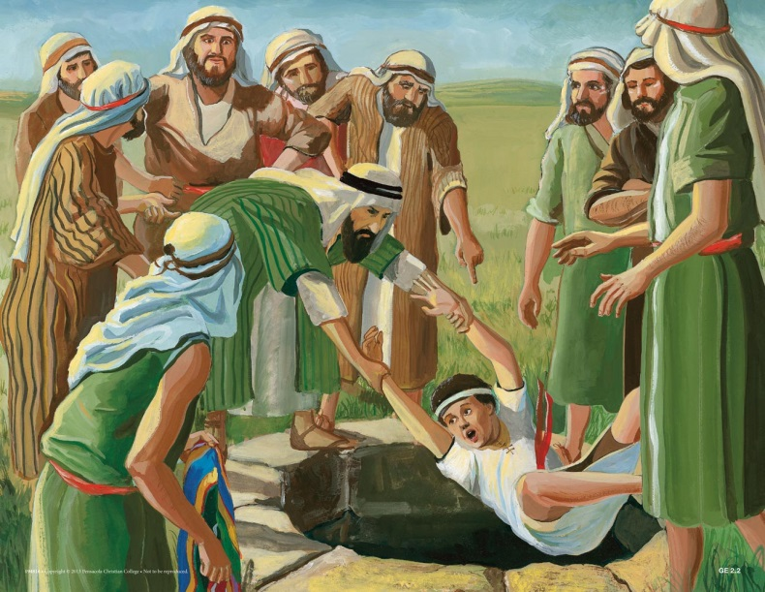
Questions: Find the facts

- Where did Jacob live?

- Why did Jacob love Joseph more? To show his love, what did Jacob do for Joseph?

- How did Joseph’s brothers feel about him?

- What made Joseph’s brothers hate him even more?

- What did Joseph’s brothers plot to do?

- Who tried to save Joseph?

- Did the plot go according to plan?

- What did the brothers tell Jacob?

- What was Jacob’s reaction?

- Where did Joseph end up?

Thought Questions: (Bring your thoughts to class or write on the back of the page.)
- In Ephesians 4:26 – 32 it tells what happens when we stay angry. What is the result?

- What can we do with our thoughts when we are tempted to stay angry? (Philippians 4:8)

From Old Testament to New Testament
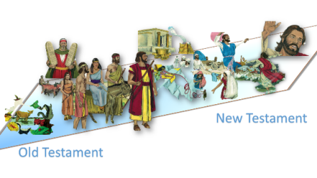
Joseph’s brothers hated Joseph. In 1 John 4:20-21, it says that we cannot love God if we do not love our brother. In 1 John 2:9-11, what is someone who hates his brother described as? Why do you suppose that he is described this way?

