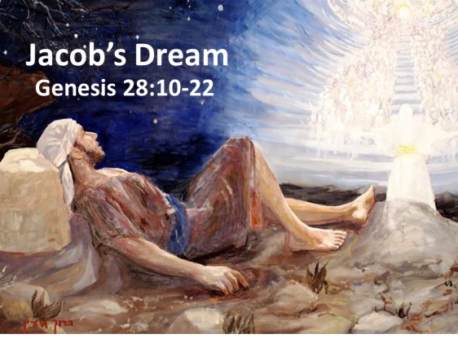
JACOB & HIS FAMILY February, 14, 2018
Genesis Chapters28-35
1-1-12

Esau surrendered his birthright to Jacob in exchange for
some stew. That wasn’t a good decision, but as we know, God had a plan to use these brothers and their imperfect character to bring about the promises he made to Abraham and Isaac. Now Jacob, Isaac’s son, will receive these same promises from God in a dream as he flees from Beersheba and Esau’s anger at his mother’s, Rebekah, request. His father also sends him away to find a wife from Laban, his mother’s brother, back home in Haran.
Jacob took a stone as a pillow and went to sleep. In his dream he saw a ladder set on earth and its top reached to heaven. Angles of God were ascending and descending on it. The Lord stood above and said, “I am the Lord, the God of your father Abraham and the God of Isaac; the land on which you lie, I will give to you and your descendants. Your descendants will be like the dust of the earth and spread out as far as you can see and all the families of the earth will be blessed by your descendants. I will keep you safe and will bring you back and won’t leave you till I have done what I promised.”
Jacob awoke and said, “Surely God is in this place”. He took the stone, built a pillar, poured oil on it and called the place Bethel. Jacob vowed if God will be with me, keep me on this journey and give me food and clothing and if I return to my father’s house safely, then I will know God is my God and He is with me.
Jacob continues his travel and meets Rachel, falls in love and offers to serve in Laban’s home for seven years in exchange for Rachel to be his wife. When the seven years were up, Laban, tricked Jacob and gave his older daughter, Leah, to Jacob instead as it was the practice to marry off the firstborn daughter first. Jacob worked another seven to marry Rachel. Rachel was not able to have children and because Leah was unloved by Jacob, the Lord blessed her with sons named Reuben, Simeon, Levi and Judah. Rachel gave her maid, Bilhah as a wife and she bore Jacob, Dan & Naphtali. Leah gave her maid, Zilpah, as a wife to Jacob and she bore two sons, Gad and Asher. Leah again conceived and bore Issachar, Zebulun and a daughter Dinah. But then God remembered Rachel and she bore to Jacob, Joseph.
Jacob leaves Haran and is on his way back home and hears his brother, Esau is coming and he thinks he is still angry and wants to kill him. Jacob is left alone after he sent his wives, children and all he has across the stream. Jacob wrestles with a man till daybreak and when he did not win, he touched Jacob’s thigh so it dislocated. Jacob would not let go. He continued wrestling until he received a blessing from the man. The man said, no longer will you be Jacob, but your name will be Israel for you have wrestled with God and with men and you have prevailed. Jacob said, “I have seen God face to face, yet my life has been preserved.” Jacob went on limping on his thigh and off to meet Esau.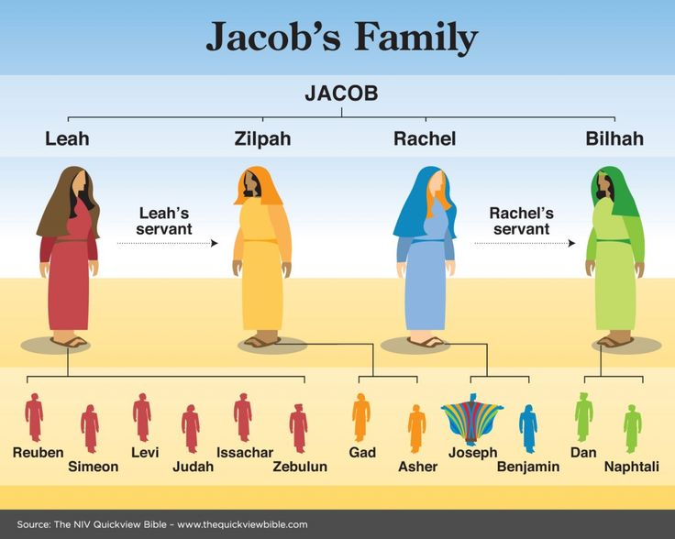

Questions: Find the facts

- Why did Rebekah send Jacob away to her family? Why did Isaac think he was going away (Gen 27:42-43; 28:1-2)?

a.What did Esau do when he heard why Jacob was leaving? (28:9)

- Describe the scene of Jacob’s dream when he was traveling toward Haran. (28:12-15). Why did God have to introduce Himself to Jacob and what did Jacob decide to do after this dream? (28:18-22)

- Who were Laban’s two daughters? (29:16-18)_____________, ______________

- Which daughter did Jacob love? ______________________

  - How did God show His mercy on the daughter Jacob didn’t love?

- Name the sons of Jacob by their mothers (Look at the end of Genesis 35)
  - Leah ________________________________________________
  - Rachel_______________________________________________
  - Bilhah _______________________________________________
  - Zilpah _______________________________________________

- What things changed for Jacob after he wrestled with a stranger? (32:24-32)

  - Who do you think the stranger was? (vs. 30)

Thought Questions: (Bring your thoughts to class or write on the back of the page.)
Jacob’s life has been full of deceit (trying to hide things and lying). Even though he is chosen by God to receive His promises, Jacob suffers some consequences of his actions and has a difficult life. Think of a few examples of this in Jacob’s life and what this means for us when we sin.

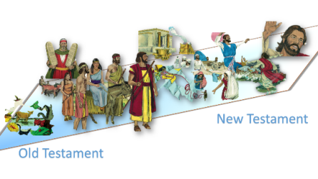
From Old Testament to New Testament
Jacob makes some big discoveries after his dream on the way to Haran.
One of the important statements he makes in his vow in Genesis 28:20
is that he only needs God to provide him with clothing and bread. I Tim 6:6-10
makes a similar statement for us. Why do you think this idea of “contentment”
(being at peace with what you have been given) is mentioned in the Old and New Testament?

