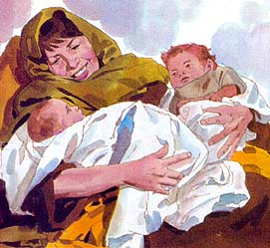
JACOB & ESAU
Genesis 25:19-34; 26:1-5, 27
February 11, 2018
1-1-11

Isaac, the son of Abraham married a woman named Rebekah. Rebekah was not able to have children, so Isaac prayed to God about it. Rebekah became pregnant with twins! The first child born was red and hairy and they named him Esau. The second son was born with his hand holding on to Esau’s heel, so they named Jacob. Esau grew up to be a skillful hunter and he was Isaac’s favorite. Jacob was a peaceful man living in tents and he was Rebekah’s favorite. One day Esau came in from the fields and he was starving. He asked Jacob to give him some of the stew he had made. Instead of gladly sharing the soup with Esau, Jacob said he wanted Esau to sell him his birthright. The birthright meant that Esau would be the leader of the family when Isaac died. Esau made a poor choice and agreed that Jacob could have the birthright in exchange for some food!
There was another famine in the land like Isaac’s father Abraham lived through, but Abraham had traveled to Egypt to find food then. This time the Lord appeared to Isaac and said, “Do not go down to Egypt; stay in the land which I shall tell you. Travel in this land and I will be with you and bless you, for to you and your descendants I will give all these lands and I will establish the oath which I swore to your father Abraham. I will multiply your descendants as the stars of heaven, and will give your descendants all these lands; and by your descendants all the nations of the earth shall be blessed because Abraham obeyed Me and kept My charge, My commandments, My statues and My laws.” And Isaac stayed in Gerar.
When Isaac was old and near death, he told Esau to kill some game and make him a savory dish to eat so he could bless Esau, the first born. Rebekah overheard the conversation and she called Jacob to her and they came up with a plan to deceive Isaac. Rebekah would make a savory dish. She would put goat skin on Jacob to make him hairy. Jacob would take the food to Isaac pretending to be Esau and Isaac would bless Jacob. The plan worked! Isaac thought Jacob was Esau and gave him the blessing. When Esau discovered what had happened he was very angry. He said he was going to kill Jacob! Rebekah learned of Esau’s plan and she sent Jacob away to protect him.
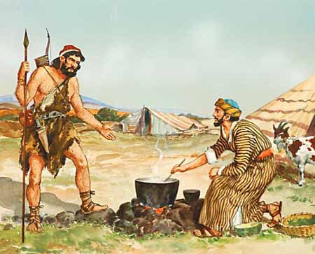
Questions: Find the facts

- How many children did Rebekah have?

- What were their names and what did they mean?

- As the boys grew, what were their personalities like?

- What did Esau do in exchange for the food Jacob gave him?

- In Genesis 26:1-5, what did the Lord tell Isaac that He had also told Abraham?

- Who received the blessing from Isaac?

- How did he receive this blessing?

- What does Jacob end up doing in 27:42 – 45?

- What does Rebekah tell Isaac?

Thought Questions:
(Bring your thoughts to class or write on the back of the page.)
Esau gave up his birthright for something to satisfy his immediate physical needs without thinking it all the way through. How do WE satisfy our physical needs without giving thought to our relationship with God?

From Old Testament to New Testament
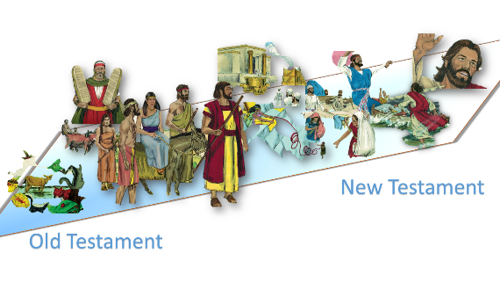
The fact that Isaac’s second son would inherit the blessing
shows that God’s plan prevails over man’s traditions.
How did Jesus prevail over man’s traditions?
Read: Matt 5:43-47; 18:21-35; 23:11-12

