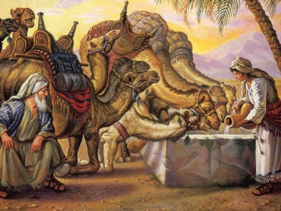
ISAAC & REBEKAH
Genesis 24
February 7, 2018
1-1-10

Sarah had died and Abraham was very old and wanted to make sure Isaac married a woman from his
brother, Nahor’s house in Haran and not marry a daughter of the Canaanites. He made his oldest and most trusted servant swear an
oath that he would find a wife for Isaac and bring her to Canaan and not take Isaac back to Haran because the Lord, the God of heaven, promised Abraham that to his descendants the Lord would give the land of Canaan.

The servant, took ten camels and many expensive items as gifts for the woman’s family and traveled to Haran. He prayed to God to grant him success and show lovingkindness to his master, Abraham. He prayed, that the woman he asks, ‘Please let down your jar so that I may drink’ and if she answers, ‘Drink, and I will water your camels also’-may she be the one whom God appointed for Isaac’s wife and if this happens, the servant will know that God showed lovingkindness to his master.

After he finished speaking, Rebekah, who was a very beautiful virgin came down to the well with her jar. The servant did not know she was the granddaughter of Nahor. He asked her for a drink and she not only offered the servant a drink, but also watered the 10 camels. She was kind, generous and had a strong work ethic. After she watered all the camels he asked her whose daughter she was and when he hear she was from the house of Nahor, he gave her gifts and she offered him to come stay at their home. The servant blessed the Lord and thanked Him for guiding him to the house of his master’s brother.

After the servant told the story to Laban and Rebekah’s father, Bethuel, how he came to find the wife for Isaac, they realized it was the Lord’s plan and they offered Rebekah to be taken as Isaac’s wife. However, Laban and her mother wanted her not to leave for 10 days, but Rebekah said she would go and not delay.

Isaac knew about the servant being sent to find a wife and when he saw the camels coming, he went to meet them and Rebekah became his wife and he loved her and was comforted after his mother’s death.

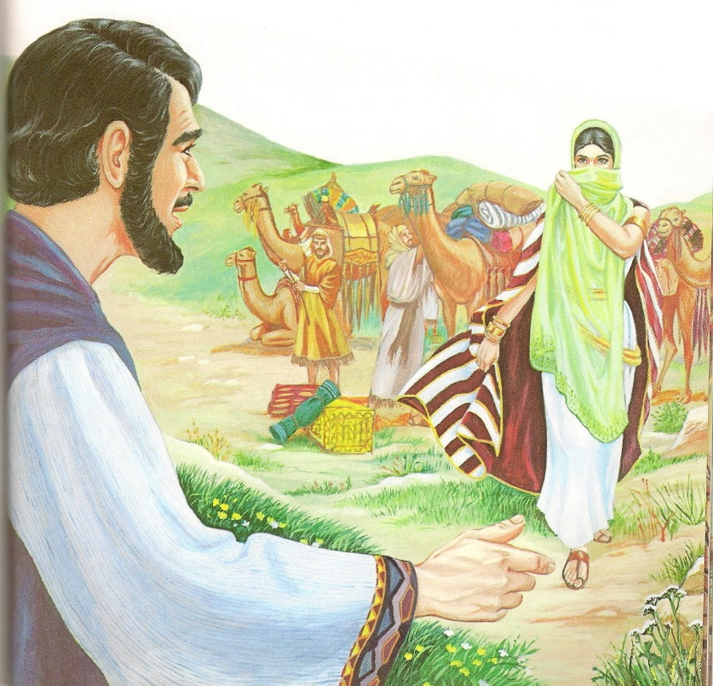
Questions: Find the facts
- Where was Abraham’s servant to find Issac a wife?
- What did Abraham make the servant promise? (verse 6,8)
- How was Rebekah described? (verse 16) What other attribute did she show to the servant?

- When Abaham’s servant had realized that he had found success, what did he do?

- After Abraham’s servant recounted the story to Laban, what did Laban realize?

- What did Rebekah’s mother and brother want her to do? Did Rebekah do as her mother and brother wanted her to do?

- How did Isaac and Rebekah feel about one another?

Thought Questions:
(Bring your thoughts to class or write on the back of the page.)
- Why do you suppose that Abraham wanted Isaac to marry someone from his own family and not someone from Canaan? How can you and I apply this wisdom to our lives?

- Did Abraham’s faith, trust, and obedience in God have an effect upon Abraham’s servant? What does this tell us about OUR choices and actions?

From Old Testament to New Testament
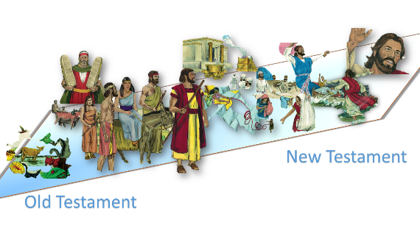
Isaac was a continuation of the promise that God gave to Abraham. How are we the continuation of this promise today? Read Galatians 3:24-29

