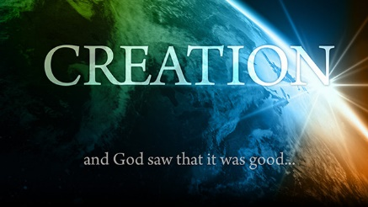
CREATION
January 3, 2018
Genesis 1

1-1-1

In the beginning, God created the heavens and the earth. The earth was formless and void, and darkness was over the surface of the deep, and the Spirit of God was moving over the surface of the waters. Then God said, “Let there be light”; and there was light. God saw that it was good; and God separated the light from the darkness. God called the light day, and the darkness He called night. And there was evening and there was morning the first day. (Genesis 1:1-5)
You just read the first five verses of Genesis chapter one! God created our world and universe out of nothingness! Please read the rest of chapter one in your Bible (verses 6-31) and be ready to talk about why God is telling us about His creation and why He choose to create things in the order He did! Did God have a plan? Explore His Word carefully!

Questions: Find the facts

- What already existed “in the beginning?” (v.1)

- What did God say about everything He created when each part was finished?

- God made man in whose image? (v.27)

- What does it mean to “be fruitful and multiply?”

- How was man’s job a little different than the animals? (v.28)
What did God do before He sent each creature and man out to live?

- Have you heard any other stories that people tell to explain Creation? How do you know if they are true or false?
(Hebrews 11:3)
Thought Questions:
(Bring your thoughts to class or write on the back of the page.)
Can you think of a reason why God might have wanted to
tell us about creation? (ex. 1 Corinthians 4:6)
- Think of some reasons why God might have created things in the order He did.

From Old Testament to New Testament
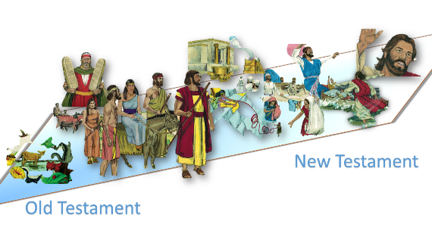
Read John 1:1-3.
Who was with God in the beginning?

