Lesson 2  Jesus Immediately Begins His Ministry |  | Mark  Reading: Mark 1:1-20  Adult Class  May 6, 2018

Overview
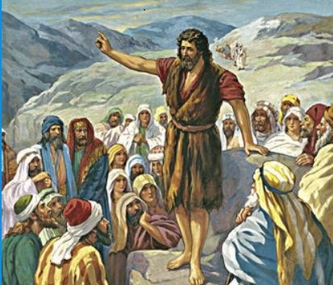
Mark starts his account of the Gospel with a prophecy from Isaiah in regard to John. The style of this book is generally regarded as “summary” and the first part of chapter 1 clearly emphasizes that. Today we want to look at the prophesy of John, John’s role in preparing the way, and some of the initial events of Jesus’ ministry.

Questions
- Mark opens with a prophesy from Isaiah 40. Read Isaiah 40:1-8. Explain the context of this passage and what it was supposed to do for the listeners of that time?

- What description does the writer of Mark give to John the Baptist 1:6?

- What was John’s objective in “preparing the way”?

- Our word “baptism” comes from the Greek word BAPTIZO which came from the Hebrew word MIZVEH. What did the original word mean and what religious connotation did it have during those times?

- What is the significance of Mark 1:10-11?

- What words does Jesus use to “start His ministry” and how to they relate to John’s preparations?

- Why was the idea of repentance so important to the beginning of the gospel?

- Describe the “pace” of this first 20 verses (16-20). What impact do you think this writing style would have had on the original audience?

