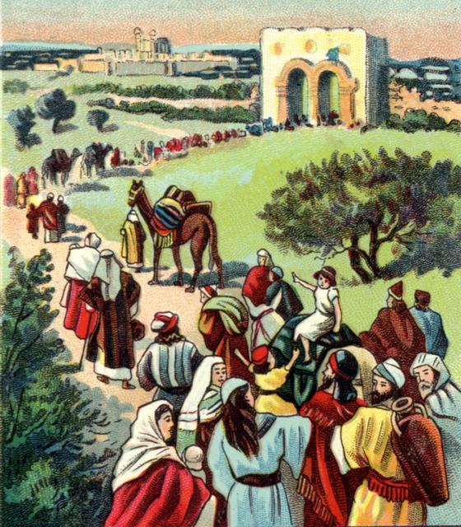
Ezra 8 Lesson 9
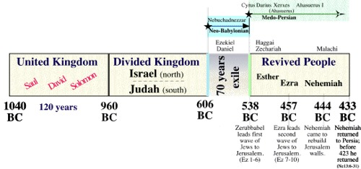
- A detailed record is kept regarding those who are returning. How many men are listed in verses 1-14, and how can we know their families went with them?

- Who is missing, and why is it important?

- What might be the value of the gifts given in the “freewill offering” in today’s currency?

- How far did they have to travel with these gifts?

- The Bible contains real stories of real people. We can know this, in part, by their human interactions. Examine verses 21-23. Have you ever put yourself in a similar situation? (Maybe a few brave souls will be willing to share their similar stories)

- Bonus Question: Who are the Nethinim?

