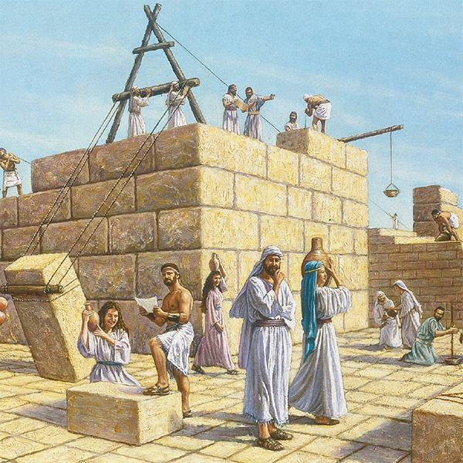
Ezra 5 Lesson 6

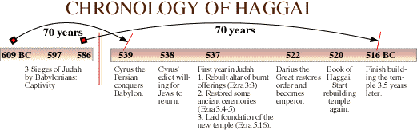
- Take a minute or two and read Haggai and Zechariah (ch. 7). What prompted the second attempt to rebuild the temple?

- How long had it been since they stopped working on the temple?

- What do you think is the motivation behind governor Tattenai’s inquiry in verse 3?

- Compare the letter sent by Tattenai to the letter written by Rehum and Shimshai:

- Also compare the historical search in Chapter 5 to the one in Chapter 4:

- Examine the spiritual condition of the people during both chapters 4 and 5. Consider your own spiritual growth. Compare this to a personal experience of “having your eyes opened.” (Refer to question 1)

