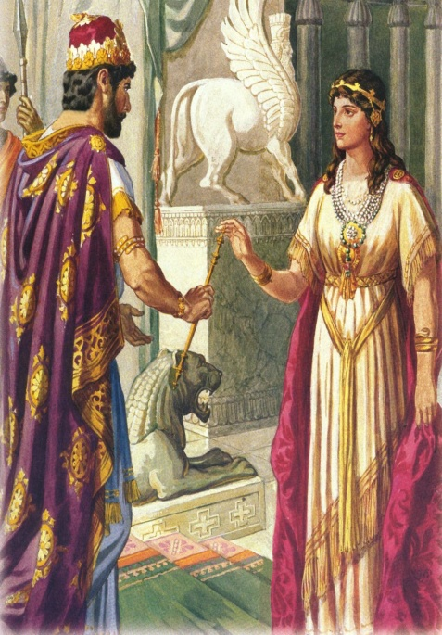
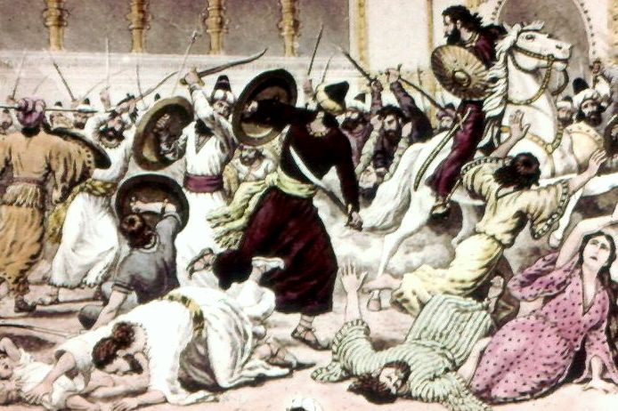
Esther Chapters 9-10

- Who ends up helping the Jews against their enemies?

- Explain what has happened to Mordecai:

- Has Mordecai done anything that seems out of character for him?

- Why would the Jews not take any of the plunder from this battle?

- Compare 9:12 to 5:1-3 and 8:3-4:

- What is the enacted feast meant to represent or bring to remembrance?

- Compare 10:3 to Daniel 2:48 and Genesis 39:3-5

