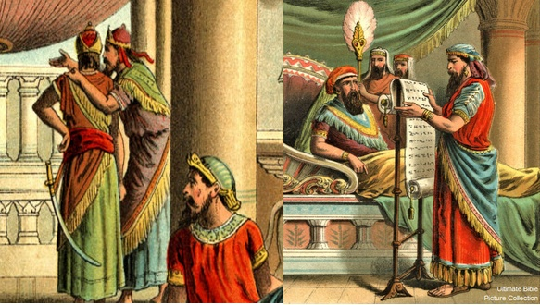
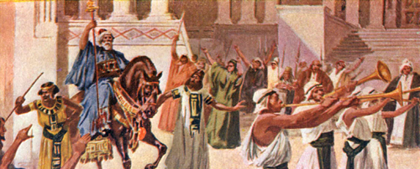
Esther Chapter 6 Lesson 28

- What is Haman’s current position in the king’s court?

- What caused Ahasuerus to decide to reward Mordecai?

- Why was Haman standing in the court so early in the morning?

- What would make Haman think the king wanted to honor him?

- Is anything the king does in chapter 6 out of character for him?

- Compare the reaction of Mordecai to the reaction of Haman in 6:12:

- What did Haman’s wife, Zeresh, say to him after he returned home? Have you seen this sentiment anywhere else in the scriptures?

