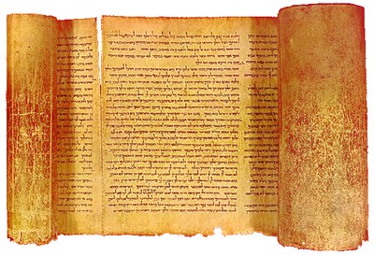
Esther Chapter 3 Lesson 25

- What position was Haman promoted to by the king?

- Why would Mordecai not bow to Haman?

- According to verses 3-4, why did Mordecai not bow to Haman? Was this an ongoing issue?

- What can we tell about Haman by his reaction to Mordecai?

- How hard was it to convince the king to allow Haman to act against the Jews?

- What was to happen to the Jews according to Haman’s letter?

- What was the mood of Susa when the orders were released to the provinces?

