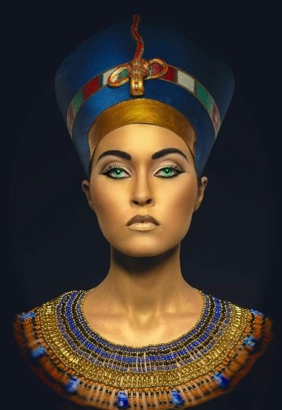
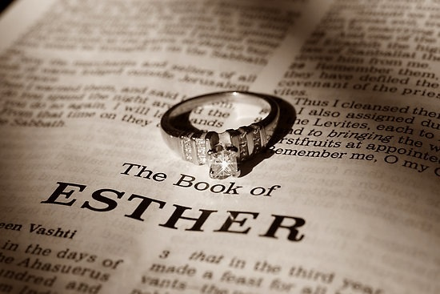
Esther Chapter 2 Lesson 24

- Once the king’s anger towards Vashti had subsided he remembers what he has done. What do his servants suggest to him?

- Who are Mordecai and Esther? How did they end up in Babylon?

- What is their physical relationship? How do they treat each other?

- Once Esther is called to the citadel, who is in charge of her group? What do we see happen with their relationship?

- Why would Mordecai not want Esther to reveal her heritage?

- Esther quickly finds favor in Hegai’s eyes and in turn the king’s eyes. How does this compare to other characters of the Bible? (Joseph, Daniel, others?)

- How is it that Mordecai finds out about the plot against the king?

