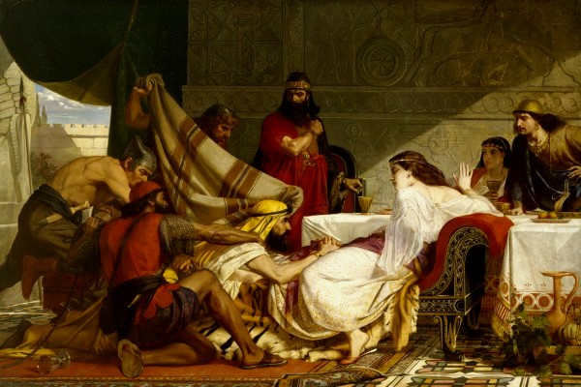

Esther Chapter 1 Lesson 23

- Before we get started, let’s review: make a brief timeline of the events since King Cyrus. Please include the kings, the prominent Jewish leaders, and significant events in Jerusalem:

- Who wrote this story?

- Describe King Ahasuerus:

- What events led to the King calling Vashti to be brought before him?

- Why would Vashti have refused the command of the King?

- What was the logic behind Memucan’s suggestion?

- What was the decree sent out to all the lands “to each province in its own script, and to every people in their own language?”

- What was the real issue behind Ahasuerus’ actions?

