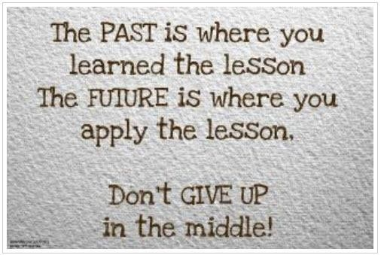
Ruth 1-4 Lesson 2
- In the grand scheme of things, who are these people?

- Why would this story be included in the Old Testament?

- As you read through the story, what is the main focus in their lives?

- In a few words, describe what you think the main lesson is from this story?

BONUS QUESTION
- There are many who describe the Bible as being full of “misogyny, violence and discrimination against women.” (bibviz.com for a colorful example) What can you use out of Ruth (and any other stories) to show this is not true:

