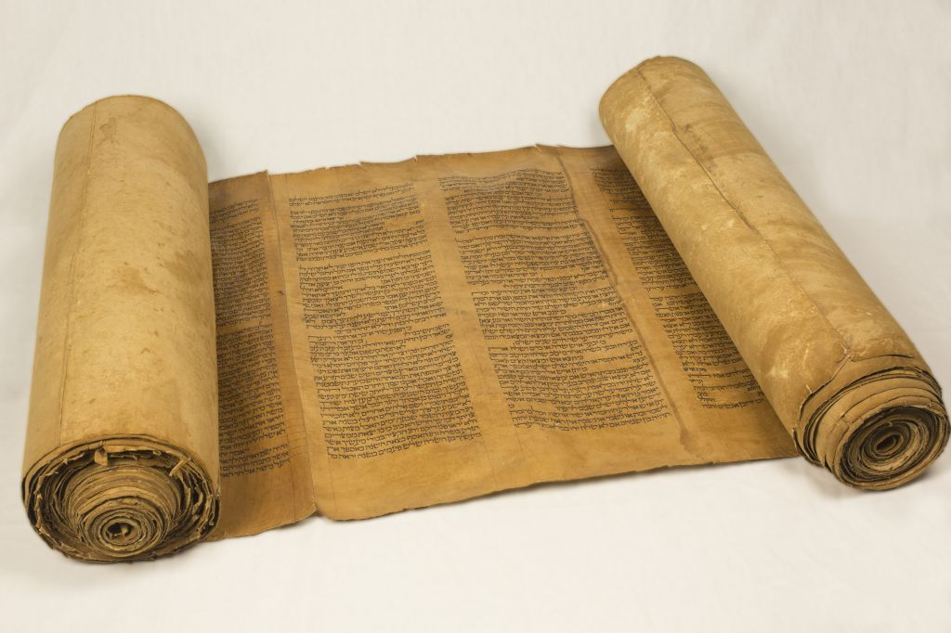
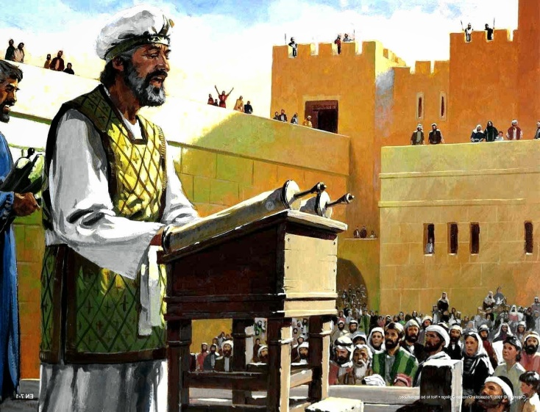
Lesson 18 Nehemiah 8

- Describe how the people were gathered in verse 1. What does this mean?

- How old would Ezra be at this time?

- The people have several reactions to the reading of the law. Describe the assembly and what was happening on this day?

- Compare this assembly to how we worship today:

- What is the condition of the hearts of the Israelites at this time?

- What is the “Feast of Booths?”

