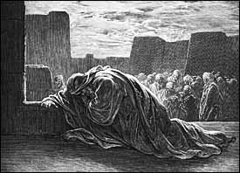
Ezra 9 Lesson 10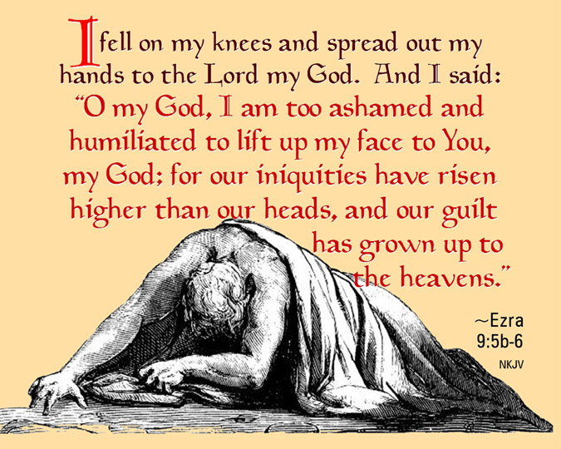

- Explain why the Israelites should have known not to take wives from the surrounding people:

- Why would Ezra have such a strong reaction upon hearing the news of the intermarriage?

- Outline and be prepared to discuss Ezra’s prayer in chapter 9:

- Is there anything about Ezra’s prayer that stands out to you personally?

