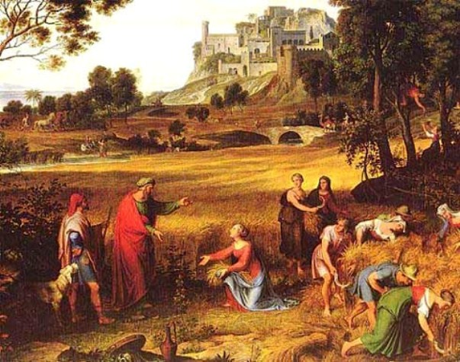
Ruth 1-4 Lesson 1 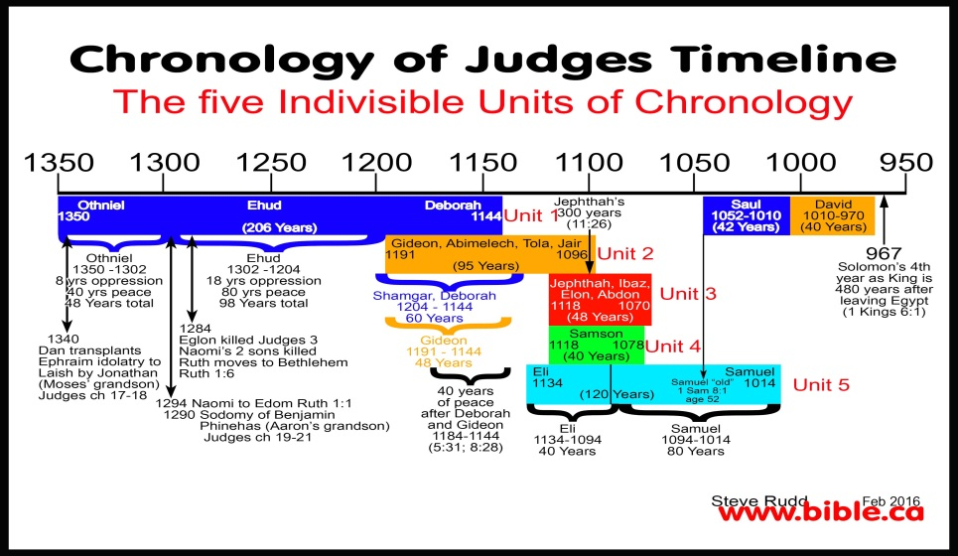

- What time period is this book written about? Use clues in the writing and see if you can narrow it down.

- Who wrote the book?

- Find out what you can about the characters in this story:
  - Elimelech
  - Naomi
  - Mahlon
  - Chilion
  - Orpah
  - Ruth
  - Moabites
  - Ephrathites
  - Boaz
- Why would Naomi change her name? Define both Naomi and Mara:

- There are certain aspects of the story that may be difficult for us to understand. See what you can find out regarding the rules of family and marriage during this time:

- What is important about the final verses of Ruth?

